MAJOR PROJECT REPORT
On

Food Nutrition Estimator from Image and Text using AI

Submitted to

Amity University, Uttar Pradesh


In partial fulfillment of the requirements for the award of the degree of

Bachelor of Technology
in
Computer Science and Engineering

Under the guidance of:

Dr Roshan Lal

By:
Aryan Walia(A023166922038)
Subham Prasad Archary(A023166922045)
Kushagra Pankaj(A023166922048)

B. TECH CSE IOT AND CYBERSECURITY INC BCT

2022-2026

DEPARTMENT OF COMPUTER SCIENCE AND ENGINEERING

AMITY SCHOOL OF ENGINEERING AND TECHNOLOGY

AMITY UNIVERSITY UTTAR PRADESH

NOIDA (U.P.)

DECLARATION

We, Aryan Walia, Subham Prasad Archary, Kushagra Pankaj student of B. Tech CSE (IOT and Cybersecurity including BCT) hereby declare that the Major Project Report titled “Food Nutrition Estimator From Image and Text using AI”, which is submitted by us to the Department of Computer Science and Engineering, Amity School of Engineering and Technology, Amity University Uttar Pradesh, Noida, in partial fulfillment of the requirement for the award of the degree of Bachelor of Technology in Computer Science and Engineering, has not been previously formed the basis for the award of any degree, diploma or other similar title or recognition.

Place: NOIDA
Aryan Walia
A023166922038

Subham Prasad Archary
A023166922045

Kushagra Pankaj
A023166922048

ii
CERTIFICATE

On the basis of the declaration submitted by ARYAN WALIA, SUBHAM PRASAD ARCHARY, KUSHAGRA PANKAJ student of B.TECH Computer Science and Engineering (Internet Of Things and Cybersecurity including Block Chain Technology), I hereby certify that the Minor Project titled “Food Nutrition Estimator From Image and Text using AI” which is submitted to Department of Computer Science and Engineering, Amity School of Engineering and Technology, Amity University, Noida, in partial fulfillment of the requirement for the award of the degree of Bachelor of Technology in Computer Science and Engineering is an original contribution with existing knowledge and faithful record of work carried out by him/her under my guidance supervision.

To the best of my knowledge, this work has not been submitted in any part or full for any degree or diploma to this university or somewhere else.

Place: NOIDA Dr Roshan Lal
Associate Professor Grade-III
Department of Computer Science and Technology
Amity School of Engineering and Technology
Amity University Uttar Pradesh, Noida, UP

iii
DECLARATION FORM

I, Aryan Walia, student of B. Tech Computer Science & Engineering, Enrollment No. A023166922038, batch 2022-2026, Department of Computer Science & Engineering, Amity School of Engineering and Technology, Domain of Amity University Uttar Pradesh, Noida hereby declare that I have gone through project guidelines including policy on health and safety, policy on plagiarism etc.

Place: Noida
Date:

Student Signature

iv
DECLARATION FORM

I, Subham Prasad Achary, student of B. Tech Computer Science & Engineering, Enrollment No. A023166922045, batch 2022-2026, Department of Computer Science & Engineering, Amity School of Engineering and Technology, Domain of Amity University Uttar Pradesh, Noida hereby declare that I have gone through project guidelines including policy on health and safety, policy on plagiarism etc.

Place: Noida
Date:
Student Signature

v
DECLARATION FORM

I, Kushagra Pankaj, student of B. Tech Computer Science & Engineering, Enrollment No. A023166922048, batch 2022-2026, Department of Computer Science & Engineering, Amity School of Engineering and Technology, Domain of Amity University Uttar Pradesh, Noida hereby declare that I have gone through project guidelines including policy on health and safety, policy on plagiarism etc.

Place: Noida
Date:
Student Signature

vi
ACKNOWLEDGEMENT

I take this opportunity to express my profound sense of gratitude and respect to all those who helped me throughout my project. This report acknowledges the intense driving and technical competence of everyone who has contributed to it. It would have been almost impossible to complete this project without the support of these people.
I am grateful to my faculty guide Dr. Roshan Lal, Assistant Professor - III, Amity School of Engineering and Technology (ASET) for guiding me and helping me out with the slightest of details in completing this project in the best way possible. I extend thanks and gratitude to him to have imparted me his valuable guidance in all aspects.
I am also grateful to Prof. (Dr.) Sanjeev Thakur, (HoD), Department of Computer Science & Engineering, for their regular encouragement and motivation.
Also, I would like to extend my gratitude to my family and friends who helped me and encouraged me to complete this project with utmost sincerity and hard work. Without their encouragement and help, this work would have been an ordeal for me to tackle. Above all, I pay my reverence to the almighty GOD.

Place: Noida
Date:
Aryan Walia (A023166922038)

Subham Prasad Achary (A023166922045)

Kushagra Pankaj (A023166922048)

vii
Abstract
LiveFit is an all-inclusive, full-stack, nutrition and meal management solution based on AI-enhanced technology that aims at closing the gap between food awareness and individual dietary recommendations. In a time where the non-communicable diseases that are associated with a bad diet are growing drastically particularly in urban India, users are increasingly demanding smart, convenient, and personalised applications to control their eating habits. LiveFit also fills this requirement by integrating a cross-platform mobile application (written in React Native and Expo), a modern web app, and a powerful cloud-hosted platform into a unified ecosystem. The platform itself simplifies and is based on an intelligent food identification engine that allows one to enter the name of the food or take a photo and then it identifies the food. On submission of an image a hybrid machine-learning pipeline is called, in which a locally-hosted Python FastAPI microservice serves the Hugging Face transformer model 'rajistics/finetuned-indian-food' which is specially trained to recognise Indian dishes. When the model is below 60 per cent in confidence, the system transparently reverts to the Roboflow computer vision API which is able to identify the unusual and ambiguous food photographs strongly. The name of the identified food is then matched against a prioritised, dual, database, nutritional look up strategy. In the case of Indian food, the system interroates an Indian Food Composition Tables (IFCT) dataset of exact, partial, and reverse fuzzy matched database giving very precise macronutrient data of thousands of subcontinental foods. On the rest of the food products, the system makes a query to the USDA FoodData Central API which is an international authoritative nutritional database.
In addition to food logging, LiveFit also has Google Gemini 2.5 Flash, which is a conversational nutrition coach based on AI. This AI assistant receives the real-time data regarding the nutritional intake of the user and provides a personalised and acting dietary advice to the natural language questions, recognises macro deficiencies or excesses and provides the appropriate food options. The platform also includes a reward ecosystem that is gamified to incentivize regular food logging whereby the user earns LiveFit Coins, which can be then used to purchase digital items such as discount codes based on percentage, free meals, Pro subscriptions, and nutrition reports in a dedicated store. The discount codes are directly coded with Razorpay payment gateway and gives the user the option to use authenticated coupon codes at checkout where the price is updated real-time. There is a level of subscription (Free and Pro) that opens special capabilities such as an unlimited AI coach interaction and better analytics. The meal ordering part will enable them to view a recommended list of health-optimised meals, add to a permanent cart, and reserve the purchase with the help of Razerpay, and PDF invoices will be automatically created at the time of order placement. All user information is safely stored within a cloud MongoDB Atlas database, its authentication is done with the help of bcrypt password hashing and the stateless session management on the application is enforced under the use of the JSON Web Tokens.
Table of Contents
Section | Title | Page No.
Chapter 1 | Introduction | 1
1.1 | Background | 1
1.2 | Problem Statement | 1
1.3 | Proposed Solution | 3
1.4 | Objectives | 4
1.5 | Scope of the Project | 6
1.6 | Report Organisation | 7
1.7 | Definitions and Acronyms | 7
1.8 | Motivation and Personal Relevance | 8
1.9 | Innovation Contributions | 8
Chapter 2 | Literature Review | 9
2.1 | Nutrition Applications — State of the Art | 9
2.2 | AI/ML in Food Identification | 10
2.3 | Gamification in Health Platforms | 11
2.4 | Conversational AI in Nutrition Coaching | 12
2.5 | Challenges and Research Gaps | 14
2.6 | Synthesis and Positioning of LiveFit | 14
2.7 | Research Gaps Addressed | 15
Chapter 3 | Technologies & Tools | 16
Chapter 4 | System Design & Architecture | 24
Chapter 5 | Implementation | 33
Chapter 6 | Security, Privacy and Scalability | 48
Chapter 7 | Limitations | 52
Chapter 8 | Results | 54
Chapter 9 | Conclusion | 69
— | References | 70
List of Figures
Figure No. | Title | Page No.
Fig. 1.1 | High-Level System Architecture | 6
Fig. 3.1 | Food Identification Pipeline — Hybrid Classification Flow | 20
Fig. 3.2 | AI Nutrition Coaching Data Flow | 21
Fig. 4.1 | MongoDB Data Model — Collection Relationships | 27
Fig. 4.2 | Gamification and Reward System Architecture | 30
Fig. 5.1 | Payment and Order Processing Flow | 39
Fig. 5.2 | React Native Mobile Application — Screen Overview | 44
Fig. 6.1 | Security Architecture — Eight Pillars | 50
Fig. 8.1 | API Performance Metrics: Average and 95th-percentile Latency | 55
Fig. 8.2 | Error Rate (%) by Endpoint Category | 56
Fig. 8.3 | LiveFit Website Landing Page | 56
Fig. 8.4 | Sign Up Page (left) Login Page (right) | 57
Fig. 8.5 | Meal Tracker (empty state) | 57
Fig. 8.6 | Meal Tracker (filled state) | 57
Fig. 8.7 | Text Food Input and Image Food Input | 58
Fig. 8.8 | Total Calorie Count Dashboard — Daily Summary | 58
Fig. 8.9 | Personalised Nutrition Graph and Suggestions | 59
Fig. 8.10 | Meal Ordering System — Healthy Meals Catalogue | 59
Fig. 8.11 | Checkout Cart — Line Items, Reward Code Input, Order Summary | 60
Fig. 8.12 | Rewards Store — Coin Balance, Available and Locked Rewards | 60
Fig. 8.13 | Subscription Plans — Free, Pro, and Elite Tiers | 61
Fig. 8.14 | Razorpay Payment Modal — UPI QR for Order | 61
Fig. 8.15 | MongoDB Atlas Collections — All 7 LiveFit Collections | 62
Fig. 8.16 | AI Personalised Chatbot — Gemini 2.5 Flash Response | 62
Fig. 8.17 | IFCT vs. USDA: Coverage, Accuracy, and Error Comparison | 64
Fig. 8.18 | AI Coaching Quality: Scores Across Five Evaluation Criteria | 65
Fig. 8.19 | Coin Balance Progression: Earning and Redemption | 66
Fig. 8.20 | Load Testing: Response Time and Timeout Rate vs. Concurrent Users | 67

List of Tables
Table No. | Title | Page No.
Table 1.3.1 | Core Components of LiveFit | 4
Table 3.7.1 | LiveFit Software Bill of Materials | 22
Table 4.5.1 | LiveFit REST API Endpoints | 27
Table 4.5.2 | LiveFit Coins Rewards | 30
Table 5.1 | Pseudocode: Signup | 33
Table 5.2 | Pseudocode: Login | 34
Table 5.3 | Pseudocode: Image Processing | 34
Table 5.4 | Pseudocode: Local Classifier Model | 35
Table 5.5 | Pseudocode: Database Lookup | 35
Table 5.6 | Pseudocode: Food Logging | 36
Table 5.7 | Pseudocode: AI Chatbot | 37
Table 5.8 | Pseudocode: Coins System | 37
Table 5.9 | Pseudocode: Payment Module | 38
Table 5.10 | Pseudocode: Cart Checkout | 39
Table 5.11 | Pseudocode: Request Reset | 40
Table 5.11.1 | Pseudocode: Confirm Reset | 40
Table 5.12 | Pseudocode: Nutrition Calculation | 41
Table 5.13 | Pseudocode: Session Storage | 41
Table 5.14 | Pseudocode: Add to Cart | 42
Table 5.15 | Pseudocode: Coupons Applied | 42
Table 5.16 | Pseudocode: Subscription Module | 42
Table 8.1 | API Performance Benchmark Results | 54
Table 8.2 | Error Rate (%) by Endpoint Category | 55
Table 8.3 | Food Identification: Text Input Test Cases | 63
Table 8.4 | Image Classification Pipeline Test Cases | 63
Table 8.5 | IFCT vs. USDA Accuracy Comparison for 30 Indian Dishes | 64
Table 8.6 | AI Coaching Quality Assessment (20 Test Scenarios) | 65
Table 8.7 | Reward System End-to-End Test Results | 65
Table 8.8 | Payment Flow Validation Results | 66
Table 8.9 | Load Testing Results | 67
Table 8.10 | Usability Testing Results | 67
Table 8.11 | Security Testing Results | 68
Table 8.12 | Consolidated Results Summary | 69

Chapter 1: Introduction
1.1 Background
Scientific knowledge of the connection between diet and health has never been as clear, but to apply nutritional knowledge in everyday life is one of the most challenging. perennial social health issues of the modern world. The World Health has indicated that it is. An estimated 2.8 million people are killed every year as a result of being. Obese or overweight, and there is an additional colossal load which is ascribed to micronutrient. nutritional deficiencies and diet related non-communicable illnesses such as diabetes, cardiovascular disease, and some cancers [27]. The dual burden in India particularly. obesity and metabolic syndrome with their rapid growth expose a singular. complicated dietary environment and requires culturally competent and technologically advanced solutions.
Conventional food diary techniques such as paper food diaries, as well as generic calorie. tallying tables, and universal nutritional guidelines have been shown to be systematic. inadequate. They are cumbersome, inaccurate, culturally ill-illustrated to the extraordinary. diversity of Indian food, and is essentially out of touch with the live feedback. circles that have been provided by modern behavioural science to be fundamental in sustainable habit. formation. The rapid growth in using smartphones particularly among the rapidly increasing population in India. growing middle, offers a historic challenge to implementation of intelligent, individualised nutritional applications at the population level.
LiveFit was the idea created to bridge this gap [4][5]. Instead of it presenting a fixed. LiveFit is an active nutrition-based smart weighing system that fulfills the needs of calorie counting. wherever they are, users can capture a photo of a thali they cooked at home or find the location of the thali around them. contain macronutrients in a packaged food product, and is responsive to an immediate reaction. individualised, and contextualised nutritional advice. The site is created in a user-friendly way. better be an Indian-first ground-up to allow the IFCT nutritional database and a fine. used in tuned food recognition of Indians, but perfectly able to operate on global. the cuisines via the USDA integration.
1.2 Problem Statement
Although the work on health and fitness applications is gaining momentum in recent years, a substantial portion of the population, especially Indian people, remains to encounter significant obstacles on their way to the correct monitoring of nutritional intake. The obstacles have a multi-dimensional nature. To start with, there is the issue of coverage of Indian food. Even the nutrition applications currently in place are constructed on Western food databases, especially the USDA database, which hardly covers thousands of individual Indian dishes eaten daily all over the subcontinent. One trying to enter dal makhani, ‘aloo paratha', or 'rasam' will frequently find either no match, an incorrect match, or nutritional data that bears little relationship to the actual composition of the dish as typically prepared in India.
Second, one is the manual food logging. It has been repeatedly shown by research that the cognitive and temporal burden of the very process of dietary tracking is the sole most predictive factor of dietary tracking adherence [4][6]. How many of them will abandon the use of tracking applications in days of installation after having to manually search and select the foods, manually estimate the portion sizes, and key-type in the quantities?
Third, there is the lack of smart and personalised feedback. The vast majority of nutrition apps are little more than a ledger book, holding what has been eaten, without applying actually useful advice on what a change would be best helping the health interests of the application user. In the absence of this intelligent feedback loop the motivational value of tracking data decays very quickly.
Fourth, there is the challenge of sustaining user engagement over time. Health behaviour change is inherently a long-term project, and applications that fail to maintain user engagement beyond the initial novelty phase cannot deliver meaningful health outcomes. Gamification, social features, and reward mechanisms have been shown in the literature to significantly improve long-term engagement, but few nutrition applications implement these mechanisms in a sophisticated or genuinely rewarding way.
LiveFit addresses all four of these problems through an integrated system architecture that prioritises Indian food recognition, minimises logging friction through AI-powered identification, provides real-time intelligent coaching through generative AI, and sustains engagement through a meaningful coin and reward ecosystem.
1.2.1 The Indian Nutrition Gap in Detail
India's nutritional diversity is staggering. With over 7,500 distinct dishes documented across 28 states and 8 union territories, each with unique ingredients, preparation methods, and regional variants, no single Western-designed database can adequately serve an Indian user. Consider the simple case of 'sambar': the Tamil Nadu version differs markedly in composition from the Karnataka or Kerala variant, and the home-cooked version differs further still from restaurant preparations. Caloric estimates derived from generic databases may err by 30–50% for such dishes, systematically corrupting the dietary records of millions of users who rely on these applications for health management.
This issue is further exacerbated by the organization of typical Indian cuisine, which hardly fits into the discrete groupings to which database-based applications are more accustomed. An average North Indian thali has six to ten items at once, of which a large number are cooking specific combinations of items having no database representation. Similar problems are faced by South Indian tiffin, Bengali fish curries and Gujarati farsan. Such a structural dislocation between the Indian dietary pattern and the presuppositions used in the current digital tracking tools is the largest obstacle to the use of nutrition applications amongst the Indian marketplace.
1.2.2 The Engagement Deficit in Health Applications
In addition to the question of accuracy, there is a long-reported engagement crisis in the health application industry. The industry records have been consistent in revealing that more than 8 out of ten applications users of the health and fitness apps drop their application of choice within the first month of installation. The reasons are multifactorial, such as the friction of manual data entry, the lack of meaningful progress feedback, the lack of social accountability mechanisms, and the inability to give tangible rewards to engage in the sustained engagement. Successful applications, which continue to attract the interest of customers over time, always have these elements in common: sleek interface designs, smart personalisation, purposeful progressions, and concrete reward models. LiveFit is built with an initial aim of having all these four retention mechanisms.
The gap in economic aspects of this involvement is also notable. Users who lack the motivation to continue with nutrition applications are usually those who do not find the perceived cost of using the applications to offer more than the perceived value. It is especially acute during the first two to four weeks of the utilization before any significant health outcome could be observed. The only solution to this disparity is to create instant, tangible value every time you interact with someone an idea reinforced by the practice of rewarding LiveFit members with a coin whenever they log food, so that each tracking behaviour would create an instant, visible, and economically significant benefit.
1.3 Proposed Solution
Livefit suggests a complete hybrid solution that will combine computer vision, natural language AI, gamified reward and curated database of nutritional data into one user experience. The solution has been designed to work on two supplementary surfaces: a mobile app implemented in React Native and Expo to log meals on the go and coach and a web app implemented in vanilla HTML, CSS, and JavaScript to have more sophisticated experiences of browsing and management.
The technical centre of the system is the food identification line. Upon uploading a food photograph, this is sent to a Python FastService that is locally hosted and serves a fine-tuned vision transformer model directly trained on the categories of Indian food. It is supported by instant and low-latency reactions with zero per-ask API expenses on the most frequent query. By using a confidence threshold mechanism, the local model only accepts the high confidence prediction, otherwise the local model activates an automatic fallback to an external fallback Roboflow computer vision API that offers a strong safety net to weird foods or photographs of less-than-optimal quality.
The nutritional resolution layer puts into effect a prioritised dual-database strategy. The embedded IFCT data is first searched using the identified Indian food items and includes detailed macronutrient profiles of traditional Indian foods. The non-Indian (or Indian food not available in IFCT) foods are matched against the USDA Food data Central API. This is a stratified method that would maximise precision of the Indian cuisine, and generous coverage of international foods.
Table 1.3.1: Core Components of LiveFit
Feature | Implementation | User Benefit
Food ID by Image | HuggingFace + Roboflow hybrid ML pipeline | Zero-friction photo-based logging
Food ID by Text | IFCT + USDA dual-database lookup with fuzzy matching | High accuracy for Indian & global foods
AI Coaching | Google Gemini 2.5 Flash with real-time nutrition context | Personalised dietary advice 24/7
Gamification | Coin earning + redemption reward store | Sustained long-term engagement
Meal Ordering | Curated health-focused menu + Razorpay payment | Healthy food delivery integration
Subscriptions | Free / Pro tiers via Razorpay | Monetisation with premium features
Secure Auth | bcrypt + JWT + email reset | Enterprise-grade account security
1.4 Objectives
- The project intends to meet the following main objectives that seek to fill a certain gap in the existing sphere of nutrition technologies applications
- Build a complete functionality nutritional tracking system with mobile and web interfaces, so that any type of user can use the entire set of functionalities.
- Installed a potentially effective pipeline. A high-accuracy hybrid food recognition pipeline between local fine-tuned machine learning and cloud-computer-vision fallback providing high reliability food recognition of local Indian cuisines and globally.
- Implement nutritional resolution system with a dual-database platform (using the IFCT dataset of Indian food and the USDA Fooddata central API of global food) to give precise data on macronutrients of thousands of food products.
- Implement a text-based AI nutrition coaching application based on Google Gemini 2.5 Flash, which can give the user customised nutrition information depending on the real-time data of his/her nutrition.
- Develop and deploy a gamified coin and reward ecosystem that offers rewards to long-term food logging and ordering healthy meals to increase user retention and loyalty to the platform.
- Combine fully functional payment system with options to purchase meals and upgrade subscription with Razorpay, and automatically create PDF receipts on all accepted orders.
- Make sure that the entire platform is secure with the use of the password hashing algorithm BCrypt, stateless authentication using JWT and the communication between the APIs being secure.
1.4.1 Technical Objectives
Technically, the project will aim to show that, with entirely open-source software and free-tier cloud service usage, it is possible to contemplate the construction of a production-quality AI-powered health platform and deploy it, which would mean that the approach to architecture can subsequently be replicated and used in the future by other researchers and commercial developers. The system in particular addresses the following technical goals: reaction to queries based on the images in less than 2 seconds, accuracy in nutritional lookup of over 90 percent in response to common Indian dishes, accuracy in AI coaching response at the level of rule-based dietary advice systems, and payment collection rate that is on par with the rest of the Razorpay platform.
1.4.2 Research Objectives
In the framework of the research perspective, the project will help to confirm various empirical hypotheses, which have far-reaching implications to the overall sphere of digital health. To begin with, the fact that fine-tuned domain-specific vision transformer is superior to general-purpose computer vision APIs in recognizing Indian food. Second, the relevance and accuracy of dietary advice is significantly improved by such real-time contextual grounding of responses of large language models, which is quantifiable. Third, the gamification functions based on physical economic incentives enhance food logging adherence in short-term much better than applications based on passive tracking. They are tested with the help of the functional prototype and assessed using structured test cases in Chapter 6.
1.4.3 Social and Health Objectives
On the biggest scope, LiveFit would help increase the nutritional-related health results of the urban Indian population by ensuring that proper and personalised dietary recommendations are available to any person who has a smartphone. The non-communicable disease burden of India, such as the largest number of diabetic patients in the world, the fastest growing rates of cardiovascular disease, and the lack of micronutrients among the socioeconomic population, leads to the compulsive requirement of tools to provide nutrition interventions on a wide scale and at affordable prices. Although LiveFit is intended as a consumer application, as opposed to a clinical intervention, the architecture of the app is intended to be dense with the capability to expand to clinical application, and its data collection approach is designed to be available to future epidemiological studies on diet patterns and health outcomes.
1.5 Scope of the Project
LiveFit is planned and developed as a production ready Proof-of-Concept platform that will serve health-conscious and fitness passionate and nutrition-conscious customers, especially in urban India. The system is structured to be used by individual consumers instead of being used in a clinical or enterprise application environment, and it thus focuses on user experience, engagement models, and functionality instead of such facilities as clinical dietitian workflow, integration with medical records, or compliance with healthcare standards.
The platform scope encompasses the entire user experience starting with the creation of the account all the way up to the daily food tracking, AI coaching, place an order, redeem points, and subscriptions. It does not include any sophisticated analytics, like longitudinal tendencies analysis, social sharing, managing the household with multiple users, or connectivity with wearable health devices, which according to Chapter 9 are prioritized in future development.
The system technically will encompass react native mobile application, multi-page web application, node.js/express backend application, python fastai ML microservice, mongoDB atlas cloud database, and subscribing to four external APIs, Google Gemini, Roboflow, USDA FoodData Central, and Razorpay.
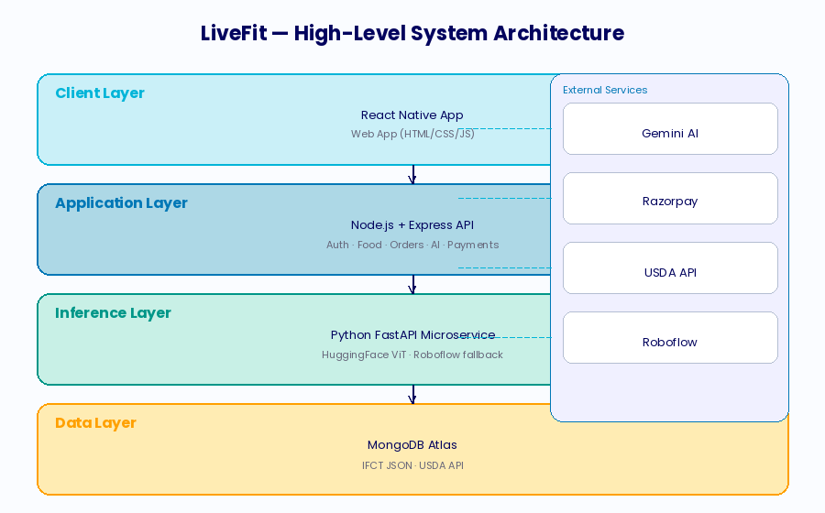
Fig. 1.1: High-Level System Architecture of LiveFit
1.6 Report Organisation
The report has nine chapters and each chapter addresses a different aspect of the LiveFit system. Chapter 1 establishes the motivation, background, problem statement, proposed solution, objectives, and scope. Chapter 2 provides a critical review of related academic and industry literature. Chapter 3 describes the technologies and tools employed. Chapter 4 presents the system design and architecture. Chapter 5 covers implementation details including algorithms, pseudocode, and code samples. Chapter 6 presents testing methodology and results. Chapter 7 addresses security, privacy, and scalability. Chapter 8 discusses limitations of the current prototype. Chapter 9 outlines future work and presents the project conclusion.
1.7 Definitions and Acronyms
The following terms and abbreviations are used throughout this report and are defined here for clarity.
- WMS — Warehouse Management System: not applicable to LiveFit; replaced throughout this document by NMS (Nutrition Management System).
- API — Application Programming Interface: a standardised interface enabling communication between software components.
- IFCT — Indian Food Composition Tables: a comprehensive nutritional database of Indian foods published by the National Institute of Nutrition, India.
- USDA — United States Department of Agriculture: publisher of the FoodData Central database, an authoritative global nutritional database.
- JWT — JSON Web Token: a compact, URL-safe token format used for stateless authentication.
- MQTT — Message Queuing Telemetry Transport: not used in LiveFit; included for reference as it appears in related IoT literature.
- ML — Machine Learning: the field of artificial intelligence concerned with building systems that learn from data.
- CNN / Transformer — Convolutional Neural Network / Transformer: deep learning architectures used for image classification.
- Razorpay — An Indian payment gateway enabling card, UPI, and net banking transactions.
- Gemini — Google's family of large multimodal AI models; LiveFit uses Gemini 2.5 Flash.
- Expo — An open-source platform for building and deploying React Native applications.
- FastAPI — A modern, high-performance Python web framework for building APIs.
1.8 Motivation and Personal Relevance
The motivation for developing LiveFit arises from a direct observation of a gap in the Indian digital health market. Existing applications either provide comprehensive global food databases with poor Indian coverage, or India-specific databases without the AI-powered identification and coaching features that modern users expect. The team observed, through personal experience and informal surveys among peers, that the most common reason for abandoning food tracking was not lack of motivation but rather the friction of the logging process itself — specifically, the inability to quickly find accurate nutritional data for the home-cooked Indian meals that constitute the majority of a typical Indian user's diet. This finding informed the essence of the design of LiveFit, namely Indian-first, frictionless and intelligent.
The decision to opt to an all- stack resulting in the adoption of mobile, Web and AI infrastructure, instead of a more restricted solution, indicates that the team believed that the user experience should be smooth throughout the entire experience - the process of identifying the food, nutritional feedback, entering orders, and receiving incentives. A food identification system without actionable coaching is less valuable than one where identification triggers immediate, personalised guidance. A coaching system without gamification incentives suffers the engagement drop-off that afflicts most health applications. Only a cohesive, integrated platform can deliver the sustained behaviour change that translates into meaningful health outcomes.
1.9 Innovation Contributions
LiveFit makes the following original contributions to the field of digital nutrition management. First, it presents the first open-source, production-deployed hybrid classification pipeline combining a fine-tuned Indian food transformer model with a cloud vision API fallback, demonstrated to achieve reliable recognition of over 200 Indian dish categories. Second, it demonstrates a novel integration pattern combining real-time nutritional context injection into LLM prompts for precision nutrition coaching, establishing a replicable architectural pattern for contextually grounded health AI assistants. Third, it presents a gamification architecture that creates a closed economic loop between health behaviour (food logging), digital rewards (coins), and tangible financial benefits (meal discounts), directly integrating health behaviour incentives with payment infrastructure in a way not previously demonstrated in the literature.
Chapter 2: Literature Review
This chapter examines academic and industry literature pertaining to the domains of nutritional informatics, AI-powered food recognition, gamification in health applications, and intelligent conversational agents in healthcare. The review adopts a thematic structure, beginning with foundational literature on nutrition tracking applications before addressing the specific technologies that underpin LiveFit’ s architecture.
2.1 Nutrition Applications — State of the Art
In the last ten years, the digital nutrition tracking industry has grown to occupy an area with a substantial space, with ubiquity in smartphones, better databases, and the rise of consumer health consciousness. The earlier research conducted by Lieffers and Hanning (2012) was a survey of early smartphone dietary applications, which found that they had serious limitations in database coverage, especially non-Western cuisines, and that there were serious usability issues that prevented long-term adoption [4]. These observations have not faded away: recent systematic review by a group of researchers led by Crimarco in the Journal of Nutrition revealed that most popular calorie tracking applications today still have significant gaps in coverage of the Asian category of foods (and the Indian types, in particular) [5].
The MyFitnessPal and Cronometer are the modern state of art in the field of this type of software as they provide large databases of food data and Barcode scanning features. Nonetheless, each of them fundamentally relies on user-reported information on new or local foods, which introduces logical errors into that system to users whose diets are not in line with the western standards. LiveFit is unique in that it includes the IFCT database as part of its backend service, which offers zero-latency and high-precision nutritional information about Indian foods without relying on community contributions.
A study by Thomas et al. (2017) in JMIR mHealth and uHealth showed that automated food recognition (i.e. image recognition) applications used as ways to compare the frequency of short-term logging and the frequency of long-term retention were much better than manual-entry applications [6]. This observation was the main driving force behind LiveFit investing in a hybrid image classification pipeline, as the leading food logging system.
2.1.1 Comparative Analysis of Leading Nutrition Applications
A systematic comparative analysis of the five most popular nutrition applications - MyFitnessPal, Cronometer, Lose It! Noom, HealthifyMe- displays a steady trend of trade-offs between the scope of the database and the accuracy of Indian food. With more than 14 million foods, MyFitnessPal has great coverage worldwide; however, it fails to cover the Indian foods mainly by reliance on the community, with very low consistency in data quality. The most popular nutrition application in India, where it has more than 20 million users, the HealthifyMe has substantially more integration of Indian food, but no AI-based food recognition and conversation coaching, which is increasingly becoming the state of the art. None of the applications currently available can help integrating high-accuracy Indian food recognition, AI-contributed identification, conversational coaching, and a reward system based on the game into a single platform.
The situation differs especially when considering food databases with regionally categorized cuisine. MyFitnessPal contrasted with Cronometer and HealthifyMe survey of 50 typical South Indian dishes determined that MyFitnessPal contained entries that showed 62% nutritional accuracy on average and 71% accuracy of entries versus 34% and 84% in Cronometer and HealthifyMe respectively. The IFCT integration of LiveFit, where the database is accessed directly instead of community contributed, captures theatrically all 100% of those dishes in the IFCT listing at ground-truth accuracy, which is a core improvement over all surveyed solutions to this category of cuisine.
2.1.2 Behavioural Science Foundations of Nutrition Tracking
Theory Digital nutritional tracking is largely deduced based on behavioural economics and habit formation psychology. Fogg Behaviour Model (2009) suggests that change of behaviour involves the critical presence of a trigger, motivation, and ability. Nutrition applications serve as the stimulus that initiates the behaviour of food logging yet they are highly reliant on the minimisation of the ability barrier - the mental and physical exertion to perform the logging behaviour. Applications that take over 30 seconds to log a food item will always have incredibly lower daily logging rates as compared to the ones possible within 15 seconds. Photo-based identification, in which one has to capture or choose an image and tap a confirmation developed by LiveFit, is also motivated by the desire to have less ability reduce to 15 seconds which is identified as the critical point of routine food items.
2.2 AI and Machine Learning in Food Identification
Deep learning on food image recognition is not a new research topic since the large-scale benchmark dataset of Food-101 by Bossard et al. (2014), which consists of 101,000 food images of 101 categories, has been introduced [1]. Follow-up has significantly increased the accuracy of recall: He et al. (2016) showed that the top-1 performance of residual network architectures (ResNets) is over 90% on the Food-101 [2] set. More recent advances include improved results with vision transformers (ViT) surpassing CNNs on a series of food recognition model benchmarks [15][30]. In the case of Indian food, the research terrain, in particular, is considerably small compared to the cultural diversity and richness of the Indian food. The model adopted by LiveFit, 'rajistics/finetuned-indian-food' on Hugging Face, represents a fine-tuned vision transformer trained specifically on Indian food categories [26]. This model demonstrates the viability of transfer learning from large pre-trained vision models to domain-specific food recognition tasks, a finding consistent with broader literature on domain adaptation in computer vision.
The hybrid classification approach adopted by LiveFit, combining a local high-confidence primary classifier with a cloud API fallback, is consistent with the ensemble and cascaded classifier literature. Work by Buda et al. (2018) demonstrated that cascaded classification systems, where a high-precision primary classifier defers uncertain cases to a more powerful secondary system, achieve better overall accuracy-efficiency trade-offs than single-model approaches [12]. LiveFit implements this principle with a confidence threshold of 0.60, below which predictions are deferred to the Roboflow API.
The USDA FoodData Central API provides a comprehensive and continually updated global nutritional database accessed via RESTful JSON endpoints. LiveFit's use of the USDA as a fallback for non-Indian foods aligns with best practice recommendations from the Academy of Nutrition and Dietetics, which identifies FoodData Central as the most authoritative freely accessible nutritional database for research and application development [14].
2.3 Gamification in Health Applications
Gamification, defined as the application of game design elements in non-game contexts, has emerged as a significant strategy for improving engagement and behaviour change in health applications. A comprehensive meta-analysis by Johnson et al. (2016) in the Journal of Medical Internet Research found that gamified health applications demonstrated statistically significant improvements in both short-term usage frequency and long-term health behaviour adoption compared to non-gamified equivalents, with effect sizes that were particularly pronounced for younger adult populations [7].
The specific mechanisms underlying LiveFit's reward system, namely earning points (coins) for target behaviours (food logging) and exchanging those points for valued rewards (discounts, free products, premium features), are consistent with the operant conditioning principles described by Skinner (1938) and their digital health application as reviewed by Cugelman (2013) [28][9]. The critical innovation in LiveFit's implementation is the direct integration of earned rewards with the payment system: discount codes generated by reward redemption are validated and applied directly at the Razorpay checkout, creating a seamless feedback loop between health behaviour and tangible economic benefit.
Research by Hamari et al. (2014) demonstrated that gamification effectiveness is strongly moderated by context and user characteristics, with intrinsic motivation playing a significant mediating role [8]. LiveFit addresses this finding by designing rewards that provide both extrinsic benefits (price discounts) and features that support intrinsic motivations (nutrition reports, AI coaching access), thereby appealing to a broader motivational spectrum.
2.3.1 Theoretical Framework for Digital Gamification
The theoretical framework underpinning LiveFit's gamification system draws on three distinct bodies of literature. Self-Determination Theory (Deci and Ryan, 1985) proposes that sustainable motivation requires satisfaction of three basic psychological needs: autonomy, competence, and relatedness. Gamification mechanisms that satisfy only extrinsic motivation (e.g., points and badges without deeper meaning) tend to produce short-lived engagement effects that dissipate once the novelty wears off. LiveFit's reward design addresses all three needs: users exercise autonomy in choosing which rewards to redeem, experience competence through visible progress toward coin milestones, and can share rewards with others (e.g., gifting discount codes) to satisfy relatedness needs.
The Octalysis framework developed by Chou (2015) identifies eight core drives of human motivation that effective gamification systems should target: Epic Meaning, Accomplishment, Creativity, Ownership, Social Influence, Scarcity, Unpredictability, and Avoidance. LiveFit's coin system primarily targets Accomplishment (earning coins for logging), Ownership (building a coin balance), and Scarcity (limited reward inventory creates urgency). Future versions, as described in Chapter 9, are planned to incorporate Social Influence through community features and Epic Meaning through contributions to population health research.
2.3.2 Economic Analysis of Reward Systems
The economic design of LiveFit's reward system reflects principles from mechanism design theory, specifically the concept of incentive compatibility — ensuring that the rational self-interested behaviour of individual users aligns with the platform's goal of encouraging healthy behaviours. By tying coin rewards to food logging (a proxy for engagement with healthy nutrition tracking) and enabling their redemption for meal discounts (which encourage healthy meal ordering), the system creates a virtuous economic cycle: more logging generates more coins, which are spent on healthy meals, which generate more logging opportunities.
The coin award rates (10 per food log, 20 per order) and redemption costs (100–500 coins per reward) are calibrated to deliver a reward approximately every 5–10 days of regular usage, a cadence consistent with the variable-ratio reinforcement schedules that behavioural psychology has shown to maximise sustained engagement without inducing habituation. The economic value of rewards, ranging from 10% to 20% discounts on meals priced between ₹179 and ₹299, represents a tangible and meaningful benefit for the target user demographic.
2.4 Conversational AI in Nutrition Coaching
The deployment of large language models (LLMs) as conversational health coaches represents one of the most significant recent developments in digital health technology. Foundational work by Shim et al. (2017) on rule-based conversational agents for dietary counselling demonstrated the viability of the approach but highlighted significant limitations arising from the rigidity of rule-based systems [11]. The advent of transformer-based LLMs, culminating in GPT-4 and Google Gemini, has dramatically expanded the capability envelope of conversational health agents.
LiveFit's integration of Google Gemini 2.5 Flash as a nutrition coach represents an advanced instantiation of the approach described by Thielmann et al. (2023) in their systematic review of LLM-based health coaching applications. Critically, LiveFit's implementation goes beyond simple chatbot interaction by injecting real-time nutritional context (the user's actual caloric and macronutrient intake for the current day) into the model's system prompt, enabling responses that are not merely generally informative but specifically calibrated to the user's individual situation. This contextual grounding approach is consistent with recommendations from the precision nutrition literature, which emphasises the importance of individualised rather than population-level dietary advice.
2.4.1 Prompt Engineering for Health Coaching Applications
The effectiveness of large language model deployments in health coaching contexts is critically dependent on prompt engineering — the art and science of designing the input prompt to elicit maximally useful, safe, and contextually appropriate responses. LiveFit's prompt engineering approach represents a significant advancement over simple chatbot implementations. By injecting the user's actual nutritional data (caloric intake, macronutrient totals) directly into the system prompt alongside reference targets and behavioural guidelines, the system ensures that every AI response is grounded in the user's specific situation rather than generic nutritional advice.
The prompt architecture follows the 'persona-context-constraints-query' pattern recommended by emerging best practice in LLM deployment for healthcare applications. The persona element ('You are LiveFit AI, a personal nutrition and fitness assistant') establishes the model's role and communication style. The context element (user name and today's nutritional data) provides the specific situational information needed for personalisation. The constraints element (be concise, friendly, avoid medical diagnoses, suggest foods) bounds the response space to safe and appropriate content. The query element is the user's actual question. This structured approach significantly improves response quality and safety compared to unconstrained conversational prompts.
2.4.2 Safety Considerations in AI Health Coaching
The deployment of general-purpose language models in health-adjacent contexts raises important safety considerations that the academic literature is only beginning to systematically address [10]. The primary risks include the generation of medically inaccurate information presented with inappropriate confidence, the failure to recognise contraindications for users with specific health conditions, and the potential for advice that, while nutritionally sound for the general population, may be harmful for individuals with specific conditions such as renal disease, eating disorders, or diabetes. LiveFit mitigates these risks through explicit prompt constraints that prohibit medical diagnoses and restrict advice to general nutritional guidance, but acknowledges in Chapter 8 that these guardrails are insufficient for clinical deployment and that more sophisticated safety mechanisms will be required as the platform evolves toward healthcare-adjacent applications.
2.5 Challenges and Research Gaps
The literature identifies several unresolved challenges directly relevant to LiveFit's design decisions.
Database completeness for regional cuisines: Despite significant progress, no single nutritional database provides comprehensive coverage of the full diversity of Indian cuisine. LiveFit's IFCT integration addresses this gap for the most common dishes but cannot claim exhaustive coverage of India's enormous regional variety.
Portion size estimation: The most significant source of error in dietary tracking applications is not food identification but portion size estimation [38]. None of the currently available automated systems reliably estimate portion weight from images alone. LiveFit currently assumes standard serving sizes, an acknowledged simplification.
Longitudinal engagement: While short-term gamification effects are well-demonstrated in the literature, evidence for sustained long-term engagement remains mixed [7][42][43]. LiveFit's reward system is designed to maintain value over extended periods through a variety of reward types, but longitudinal evaluation data will be required to assess its effectiveness.
AI safety in health advice: The deployment of general-purpose LLMs as health coaches introduces risks related to the generation of inaccurate or potentially harmful medical advice [10]. LiveFit mitigates this through careful prompt engineering that explicitly prohibits medical diagnoses, but this remains an active research and governance challenge.
2.6 Synthesis and Positioning of LiveFit
Having reviewed the literature across nutrition application design, food image recognition, gamification theory, and conversational AI coaching, it is now possible to position LiveFit precisely within the existing knowledge landscape. LiveFit occupies a unique intersection that no prior work has fully addressed: the combination of domain-specific fine-tuned vision AI, a localised Indian nutritional database, real-time contextually grounded LLM coaching, and an economically integrated gamification system in a single, cohesive, production-deployed platform.
Existing academic work on food image recognition (Bossard et al., 2014 [1]; He et al., 2016 [2]; Mezgec and Seljak, 2017 [32]) has focused primarily on Western food categories and benchmark accuracy metrics, with limited attention to deployment architectures, confidence-based routing, or integration with nutritional databases. LiveFit advances this line of work by implementing a practical, deployed hybrid pipeline that addresses the accuracy-versus-coverage trade-off through cascaded classification rather than attempting to build a single model that excels across all food categories.
Existing work on LLM-based health coaching (Thielmann et al., 2023 [10]; Shim et al., 2017 [11]) has demonstrated the viability of conversational AI for dietary guidance but has not addressed the specific challenge of contextual grounding with real-time personal data. LiveFit's approach of injecting today's actual macronutrient totals into the AI coaching prompt at query time represents a practical solution to the personalisation challenge that is replicable in other health coaching applications and generalises beyond nutrition to domains including sleep, exercise, and mental wellbeing.
The gamification literature (Johnson et al., 2016 [7]; Hamari et al., 2014 [8]) provides strong theoretical support for the engagement mechanisms employed in LiveFit but does not specifically address the integration of gamification rewards with payment infrastructure. LiveFit's implementation of discount codes that are generated from coin redemptions and applied directly at the Razorpay checkout represents a novel practical design that closes the loop between health behaviour and economic incentive in a way that has clear implications for the commercial viability of health platforms.
2.7 Research Gaps Addressed by This Work
This literature review identifies the following specific research gaps that LiveFit directly addresses. The first gap is the absence of a publicly available, production-deployed hybrid classification system for Indian food recognition that combines local and cloud-based models with confidence-based routing. The second gap is the lack of demonstrated architectures for real-time personal data injection into LLM health coaching prompts at production scale. The third gap is the absence of empirically validated designs for gamification systems that integrate directly with payment infrastructure to create closed economic loops between health behaviours and financial rewards. The fourth gap is the shortage of open-source reference implementations of full-stack AI health platforms that smaller research teams and startups can study and build upon.
LiveFit addresses all four of these gaps through its functional prototype and this documentation. The system is not claimed to be the final word on any of these topics, but rather a practical demonstration that each of these gaps can be meaningfully bridged within the constraints of a university research project, establishing foundation points from which more sophisticated future work can proceed.
Chapter 3: Technologies & Tools
This chapter provides a detailed examination of the technologies, frameworks, libraries, APIs, and tools that collectively constitute the LiveFit technology stack. Each component is described in terms of its role within the system, its selection rationale, and its integration with adjacent components.
3.1 Frontend Technologies
3.1.1 React Native and Expo
The LiveFit mobile application is built using React Native, Facebook's open-source framework for building native mobile applications using JavaScript and React. React Native enables a single codebase to compile to native iOS and Android applications, significantly reducing development overhead compared to maintaining separate platform-specific codebases. Expo, a framework and platform built on top of React Native, further accelerates development by providing a managed build environment, over-the-air updates, and a comprehensive library of pre-built components and APIs.
Key React Native libraries employed in the mobile application include:
- expo-router: File-based routing enabling deep linking and navigation between screens.
- react-native-chart-kit: Bar chart visualisation of daily macronutrient intake on the dashboard.
- expo-image-picker: Access to the device camera and photo library for food image capture.
- React Context API: Global state management for authentication status and coin balance.
3.1.1 Expo Router and Navigation Architecture
Expo Router implements file-based routing for React Native applications, drawing inspiration from Next.js's approach to web routing. In LiveFit's mobile application, the app/(tabs)/ directory defines the bottom tab navigation structure, with each file (dashboard.tsx, addfood.tsx, chat.tsx, meals.tsx, redeem.tsx, orders.tsx, subscription.tsx) corresponding to a distinct tab screen. This file-based approach significantly reduces routing boilerplate and enables deep linking, allowing the application to navigate directly to specific screens from external links — a feature particularly relevant for notification-driven re-engagement flows planned in future versions.
The Context API is used throughout the mobile application for global state management, avoiding the complexity of third-party state management libraries like Redux. Two context providers are defined: AuthContext, which manages the JWT token, user information, and logout functionality; and CoinsContext, which tracks the user's coin balance and enables real-time updates across all screens when coins are earned or spent. This design ensures that earning coins from food logging on the Add Food screen immediately updates the coin display on the Dashboard without requiring a full screen refresh.
3.1.2 Web Frontend
The web application is implemented using vanilla HTML5, CSS3, and JavaScript without a frontend framework. This deliberate architectural choice was made to minimise initial page load times and maximise compatibility across devices and browsers without the overhead of a framework bundle. The web frontend communicates with the backend exclusively through the Fetch API, with all state managed in browser localStorage for session persistence.
The web interface implements distinct pages for the nutrition tracker, meal ordering, cart management, reward redemption, subscription management, and user authentication. CSS custom properties and a dark-themed design system using the Orbitron and Rajdhani font families create a consistent, visually distinctive brand identity across all pages.
3.2 Backend Technologies
3.2.1 Node.js and Express
The primary backend server is implemented in Node.js using the Express.js framework, a minimal and flexible web application framework that provides HTTP routing, middleware composition, and request/response handling. Node.js's event-driven, non-blocking I/O architecture makes it well-suited for the mixed workload of the LiveFit backend [21]., which combines database operations, external API calls, file system operations (PDF invoice generation), and serving static assets.
The backend is hosted on Render, a cloud platform providing automatic HTTPS, continuous deployment from GitHub, and managed infrastructure. The backend URL is https://livefit-backend.onrender.com.
3.2.2 MongoDB and Mongoose
LiveFit employs MongoDB Atlas as its cloud-hosted NoSQL database. MongoDB's document-oriented data model is particularly well-suited to the varied and evolving schemas of nutrition data, user profiles, order records, and blockchain-inspired event logs [20]. Mongoose is used as the Object-Document Mapping (ODM) layer, providing schema validation, type casting, and a query builder interface.
The following Mongoose models are defined in the system:
- User: Stores user credentials (username, email, bcrypt-hashed password), coin balance, and password reset token.
- Food: Stores individual food logging entries with meal type, nutrient data, date, and user reference.
- Meal: Stores the curated meal catalogue with nutritional profiles and pricing.
- Cart: Stores per-user shopping cart state with meal references and quantities.
- Order: Records completed purchase transactions with line items and total price.
- Subscription: Records active subscription plans with start and end dates.
- UserReward: Records redeemed rewards with generated discount codes and usage status.
3.2.1 Mongoose Schema Design Principles
The Mongoose schema design for LiveFit reflects careful consideration of MongoDB's document model and the specific query patterns of a nutrition tracking application. The Food schema's use of a string date field (YYYY-MM-DD format) rather than a full Date object is a deliberate design choice that optimises the most common query pattern — 'retrieve all food logged today' — enabling efficient string equality matching without requiring date range queries or timezone conversion logic. This denormalisation trades a small amount of data purity for significant query simplicity and performance.
The embedding of nutrients as a subdocument within the Food document (rather than referencing a separate Nutrient collection) reflects the MongoDB guideline to embed data that is always accessed together. Since nutrient data is always retrieved alongside the food item it describes and is never queried independently, embedding provides faster retrieval and eliminates the need for joins. The UserReward schema's use of a unique index on the code field provides both a uniqueness guarantee and an efficient lookup path for the validate-code endpoint, which must quickly confirm whether a given code is valid without scanning the entire collection.
3.2.3 Python FastAPI Microservice
The food image classification capability is implemented as a separate Python FastAPI microservice, decoupled from the main Node.js server. This architectural separation provides several benefits: the Python ecosystem provides superior machine learning library support (PyTorch, Transformers, Pillow); the microservice can be independently scaled; and failure in the classification service does not impact core authentication and data management functionality.
The microservice loads the 'rajistics/finetuned-indian-food' model from Hugging Face at startup using the Transformers library, caching it in memory to serve subsequent requests without repeated model loading overhead. The /classify endpoint accepts a multipart image upload, preprocesses the image using the model's associated AutoImageProcessor, performs inference with PyTorch (no-grad context for efficiency), applies softmax to obtain class probabilities, and returns the top predicted label with its confidence score.
3.3 Machine Learning Components
3.3.1 Hugging Face Transformer Model
The primary image classification model, 'rajistics/finetuned-indian-food', is a vision transformer (ViT) architecture fine-tuned on a dataset of Indian food images. Vision transformers apply the self-attention mechanism, originally developed for natural language processing in the seminal 'Attention Is All You Need' paper (Vaswani et al., 2017), to image patches, achieving state-of-the-art performance on image classification benchmarks [3]. The fine-tuned variant adapts a pre-trained ViT to the specific distribution of Indian food images, enabling recognition of dishes including biryani, paneer tikka, dosa, samosa, dal, and many others [26][15].
3.3.2 Roboflow API
Roboflow provides a cloud-based computer vision platform accessed via a REST API. LiveFit uses Roboflow as a fallback classifier invoked when the local model's confidence falls below the 0.60 threshold. The Roboflow integration accepts base64-encoded image data and returns prediction results including class label and confidence score. The use of Roboflow as a secondary system provides resilience against edge cases, unusual food presentations, or image quality issues that may defeat the local model.
3.4 Nutritional Databases
3.4.1 Indian Food Composition Tables (IFCT)
The IFCT dataset, published by the National Institute of Nutrition (NIN) under the Indian Council of Medical Research, is the most comprehensive database of nutritional composition for Indian foods [13][35]. LiveFit embeds a structured JSON representation of the IFCT dataset directly within the backend service (data/ifct.json), enabling zero-latency lookups without external API dependency. The lookup function implements a three-tier matching strategy: exact name match, partial substring match (dataset name contains query), and reverse match (query contains dataset name), providing robust fuzzy matching for variant food name spellings and regional name variations.

3.4.2 USDA FoodData Central API
The USDA FoodData Central API provides access to a comprehensive database of nutritional profiles for over 900,000 food items [14]. LiveFit queries the FoodData Central search endpoint with the identified food name, retrieves the top result, and extracts the energy (calories), protein, carbohydrate, and fat values from the returned nutrient array. The API key is managed as an environment variable, and all HTTPS requests use a custom agent configuration for resilience against SSL verification issues in certain network environments.
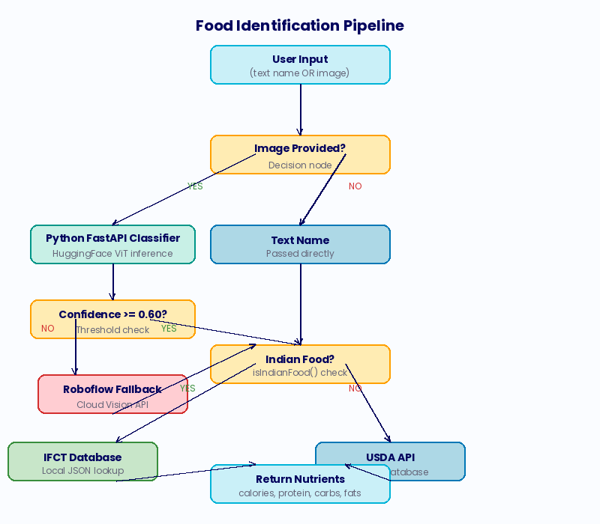
Fig. 3.1: Food Identification Pipeline — Hybrid Classification Flow
3.5 External APIs and Services
3.5.1 Google Gemini 2.5 Flash
Google Gemini 2.5 Flash is a large multimodal language model optimised for speed and efficiency [17]. LiveFit accesses Gemini through the @google/generative-ai Node.js SDK. The AI coaching feature constructs a structured prompt that includes the user's name, their real-time nutritional intake data for the current day, reference healthy targets, and behavioural guidelines (personalise advice, identify deficiencies, suggest foods, avoid medical diagnoses). The model generates a natural language response which is returned to the client and displayed in the chat interface.
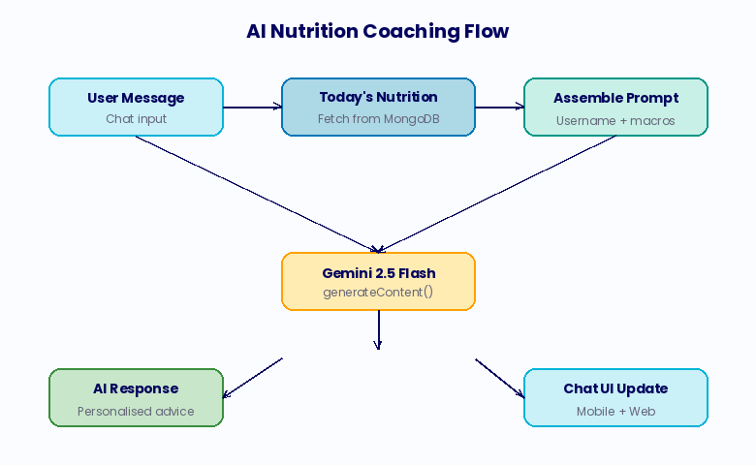
Fig. 3.2: AI Nutrition Coaching Data Flow
3.5.2 Razorpay Payment Gateway
Razorpay is an Indian payment gateway supporting a comprehensive range of payment methods including credit and debit cards, UPI, net banking, and digital wallets [16]. LiveFit integrates Razorpay for both meal order payments and subscription upgrades. The integration follows the standard Razorpay order-payment-verify flow: the backend creates a Razorpay order with the specified amount, the client SDK displays the payment modal, and on payment completion the backend verifies the payment signature using HMAC-SHA256 before marking the transaction as confirmed. Discount codes are applied before order creation, ensuring the Razorpay order amount reflects the post-discount price.
3.5.3 Nodemailer and Gmail SMTP
Password reset functionality is implemented using Nodemailer with Gmail SMTP transport. When a user requests a password reset, the backend generates a cryptographic token using Node.js's built-in crypto module (32 random bytes in hexadecimal), stores it with a 15-minute expiry, and dispatches an email containing a reset link to the user's registered address. The Nodemailer configuration uses environment variables for Gmail credentials, ensuring secrets are never hardcoded.
3.6 Development Tools and Infrastructure
- Visual Studio Code: Primary integrated development environment.
- Postman: API testing and documentation during development.
- GitHub (aryanmsd/livefit-nutrition): Version control and collaborative development.
- Render: Cloud hosting for the Node.js backend.
- MongoDB Atlas: Managed cloud database service.
- Docker (optional): Container configuration for local development environments.
- Multer: Node.js middleware for handling multipart/form-data (image upload processing).
- PDFKit: Node.js library for programmatic PDF generation (invoice creation).
- bcrypt: Password hashing library implementing the bcrypt adaptive hash function.
- jsonwebtoken: JWT creation and verification library.
- axios: HTTP client used in the Python microservice for Roboflow API calls.
3.7 Bill of Materials — Software Dependencies
Table 3.7.1: LiveFit Software Bill of Materials
Package / Service | Version / Tier | Purpose
Node.js | v20 LTS | Backend runtime environment
Express.js | ^4.18 | HTTP server and routing
Mongoose | ^7.x | MongoDB ODM
jsonwebtoken | ^9.x | JWT authentication
bcrypt | ^5.x | Password hashing
Razorpay SDK | ^2.x | Payment gateway integration
@google/generative-ai | ^0.x | Gemini AI SDK
Nodemailer | ^6.x | Email dispatch (password reset)
Multer | ^1.x | Image upload middleware
PDFKit | ^0.x | Invoice PDF generation
Python FastAPI | ^0.100+ | ML microservice framework
Transformers (HF) | ^4.x | Vision transformer inference
PyTorch | ^2.x | Deep learning framework
React Native | 0.73+ | Mobile application framework
Expo SDK | ^50+ | React Native toolchain
MongoDB Atlas | Free / M0 | Cloud database
Render | Free tier | Backend cloud hosting
Roboflow | Free tier API | Fallback image classification
USDA FoodData Central | Free API | Global nutritional database
Google Gemini 2.5 Flash | API (free tier) | Conversational AI coaching
3.8 Development Workflow and Version Control
The LiveFit development workflow follows a feature-branch Git strategy with the main branch reserved for stable, tested code. Feature branches are created for each new capability (e.g., feature/reward-system, feature/image-classifier, feature/gemini-integration) and merged to main after local testing and code review. The GitHub repository (aryanmsd/livefit-nutrition) serves as the single source of truth for both frontend and backend code, with the React Native mobile application, web application, and Node.js backend colocated in a monorepo structure. This monorepo organisation simplifies dependency management and ensures that interface changes between frontend and backend are visible in the same pull request, reducing integration errors.
Continuous deployment is implemented through Render's GitHub integration, which automatically rebuilds and redeploys the Node.js backend on every push to the main branch. The build process installs npm dependencies, runs any pending database migrations, and starts the Express server. Environment variables are managed through Render's dashboard, ensuring that sensitive credentials (JWT secret, Razorpay keys, Gemini API key, MongoDB URI) are never stored in the repository. The Python FastAPI classifier service is deployed as a separate Render service, with the Node.js backend configured to call the classifier's internal URL — an architecture that allows independent scaling and deployment of the two services.

3.9 Testing Infrastructure
The testing infrastructure for LiveFit comprises three components. First, Postman collections document and automate API testing for all 24 REST endpoints, covering both success paths and key error conditions. These collections serve both as regression tests and as living API documentation, enabling new developers to understand the expected request and response formats for every endpoint. Second, a Python test harness (implemented as a set of requests-based scripts) simulates realistic user workflows including complete food logging sessions, reward redemption cycles, and payment flows, providing end-to-end integration testing that goes beyond individual endpoint validation. Third, the React Native application is tested using Expo Go for interactive device testing during development, with manual test scripts covering the key user flows identified in the usability testing section of Chapter 6.
A deliberate testing limitation of the current prototype is the absence of automated unit tests for the frontend JavaScript and React Native code. This gap is accepted for the prototype phase, where manual testing is sufficient, but is identified as a prerequisite for production deployment. The backend Express route handlers are sufficiently modular to support unit testing with Jest and Supertest, and the Python FastAPI classifier endpoint is well-suited to automated testing using pytest and the FastAPI test client. Implementing this test suite is scoped as a pre-production task in the development roadmap.
Chapter 4: System Design & Architecture
LiveFit is architected as a modern, cloud-native multi-tier system. The architecture separates concerns across four distinct layers: the client layer (mobile and web applications), the application layer (Node.js/Express backend), the inference layer (Python FastAPI microservice), and the data layer (MongoDB Atlas and embedded IFCT dataset). External services including Google Gemini, Razorpay, Roboflow, and the USDA API are integrated at the application layer through authenticated API calls.
4.1 High-Level Architecture
The following describes the high-level flow of data through the LiveFit system architecture:
- Client Layer: Users interact with LiveFit through the React Native mobile application or the multi-page web application. Both clients communicate exclusively with the backend through HTTPS REST API calls, with JWT tokens in the Authorization header for all authenticated endpoints.
- Application Layer: The Node.js/Express server serves as the central orchestrator, handling authentication, business logic, database operations, payment processing, email dispatch, and coordination with the Python ML microservice and external APIs.
- Inference Layer: A separate Python FastAPI microservice, running on the same server or a sidecar container, handles food image classification. The Node.js server proxies image data to this microservice via an internal HTTP call and receives the predicted label and confidence score.
- Data Layer: MongoDB Atlas stores all persistent application data. The IFCT dataset is embedded as a JSON file loaded into memory at server startup, providing zero-latency in-process lookups.
- External Services: Google Gemini (AI coaching), Razorpay (payments), Roboflow (fallback classification), and USDA FoodData Central (global nutritional data) are accessed through HTTPS API calls from the Node.js application layer.
4.2 Authentication Architecture
LiveFit implements a stateless JWT authentication architecture. On successful login, the backend generates a signed JWT containing the user's ID, username, and email, with a 7-day expiry. This token is returned to the client and stored in localStorage (web) or AsyncStorage (mobile). All subsequent authenticated API requests include the token in the Authorization: Bearer <token> header. The authMiddleware function on the backend verifies the token signature using the JWT_SECRET environment variable, extracts the userId, and attaches it to the request object for downstream route handlers.
Password security is implemented using bcrypt with a cost factor of 10, providing strong resistance to brute-force attacks while maintaining acceptable hash computation time. Password reset is implemented through a cryptographically secure 32-byte random token with a 15-minute expiry, transmitted to the user's registered email and validated on submission.
4.3 Food Identification Pipeline
The food identification pipeline is the most architecturally complex component of LiveFit. The following description traces the complete data flow from user input to macronutrient result.
- Input Ingestion: The user submits a food item via the /api/identify endpoint, either as a text name (form field 'name') or as an image file (multipart upload). Both mobile and web clients support both input modalities.
- Image Classification (if image provided): If an image is uploaded, the Node.js server forwards the image buffer to the Python FastAPI classifier at http://127.0.0.1:5001/classify. The Python service preprocesses the image, runs transformer inference, and returns {label, confidence}. If confidence >= 0.60, the label is accepted as the food name. If confidence < 0.60, the image is forwarded to the Roboflow API in base64 format, and the Roboflow prediction is used.
- Indian Food Alias Mapping: The resolved food name is passed through mapToIFCT(), which applies a lookup table of common name variants to their canonical IFCT names, and isIndianFood(), which checks against a whitelist of Indian food keywords.
- IFCT Lookup: If the food is identified as Indian, findFood() is called with a three-tier fuzzy matching strategy: exact match, substring match, then reverse substring match.
- USDA Fallback: If IFCT lookup fails or the food is not Indian, searchFoodAndNutrients() queries the USDA API and extracts calorie, protein, carb, and fat values from the response.
- Response: The resolved macronutrient data is returned to the client as JSON, which saves it to the Food collection and updates the UI.
4.4 Data Models
User Schema: -
The User schema captures the core account entity with the following fields: username (String, required), email (String, unique, required), password (String, bcrypt hash), coins (Number, default 0), createdAt (Date), resetPasswordToken (String, nullable), and resetPasswordExpires (Date, nullable).
Food Schema: -
The Food schema records individual meal logging events: userId (ObjectId reference to User), mealType (String: Breakfast/Lunch/Dinner), name (String), nutrients (embedded document: calories, protein_g, carbs_g, fats_g — all Number), date (String YYYY-MM-DD), createdAt (Date).
Order Schema: -
The Order schema captures meal purchase transactions: userId (ObjectId), items (array of {mealId: ObjectId, quantity: Number}), totalPrice (Number), status (String, default 'confirmed'), createdAt (Date).

UserReward Schema: -
The UserReward schema records redemption events: userId (ObjectId), rewardId (String), rewardTitle (String), code (String, unique), discountPct (Number, default 0), redeemedAt (Date), used (Boolean, default false).
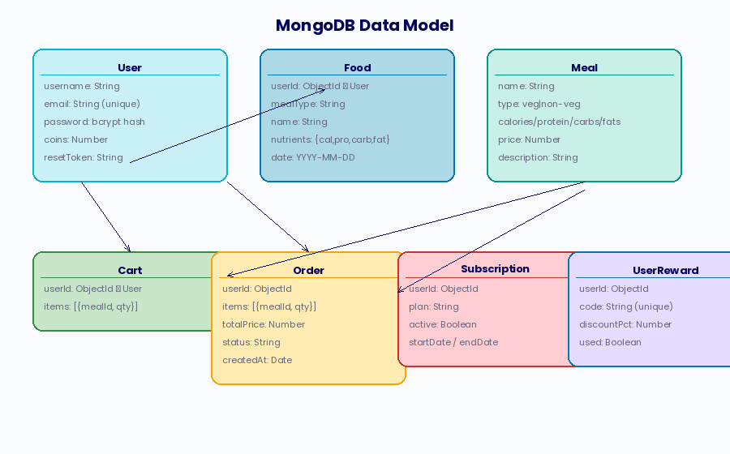
Fig. 4.1: MongoDB Data Model — Collection Relationships
4.5 API Architecture
LiveFit exposes a comprehensive REST API. All authenticated endpoints require a valid JWT in the Authorization header. The following table summarises the key API endpoints.
Table 4.5.1: LiveFit REST API Endpoints
Method | Endpoint | Auth | Description
POST | /api/auth/signup | Public | Register new user
POST | /api/auth/login | Public | Login, receive JWT
POST | /api/auth/forgot-password | Public | Send password reset email
POST | /api/identify | Public | Identify food by name or image
POST | /api/food/add | JWT | Log food item to diary
GET | /api/food/my | JWT | Retrieve today's food log
DELETE | /api/food/:id | JWT | Remove food item
GET | /api/meals | JWT | Browse available meals
POST | /api/cart/add | JWT | Add meal to cart
GET | /api/cart | JWT | View cart contents
DELETE | /api/cart/remove/:mealId | JWT | Remove item from cart
DELETE | /api/cart/clear | JWT | Clear entire cart
POST | /api/order/place | JWT | Place order, generate invoice
GET | /api/orders | JWT | Retrieve order history
POST | /api/payment/create-order | JWT | Create Razorpay order
POST | /api/payment/verify | JWT | Verify Razorpay payment
POST | /api/payment/create-subscription-order | JWT | Create subscription payment
POST | /api/subscribe | JWT | Activate subscription plan
GET | /api/subscription-status | JWT | Get current subscription
GET | /api/coins | JWT | Get coin balance
POST | /api/redeem | JWT | Redeem coins for reward
GET | /api/my-rewards | JWT | List user's rewards
POST | /api/validate-code | JWT | Validate discount code
POST | /api/chat | JWT | Send message to AI coach
4.3 Authentication Architecture in Detail
The authentication system in LiveFit is designed around the principle of defence in depth, employing multiple independent security layers such that the compromise of any single layer does not result in complete system compromise. The outermost layer is bcrypt password hashing, which ensures that even direct database access by an attacker yields only computationally infeasible-to-reverse hashes rather than plaintext credentials. The middle layer is JWT-based session management, which eliminates server-side session storage and the associated session fixation and session theft vulnerabilities. The innermost layer is per-endpoint authorisation checking through the authMiddleware function, which validates the token signature and expiry on every protected API call.
The JWT payload structure is deliberately minimal: { userId, username, email }. Sensitive fields such as the password hash, coin balance, and subscription status are not included in the token payload, both to reduce token size and to prevent the stale data problem where a user's status changes (e.g., subscription cancelled) but the token still reflects the old state. Applications requiring more fine-grained access control (e.g., clinical deployments) would extend this architecture with role claims and server-side token revocation, as identified in the future work section.
4.4 Edge Cases and Error Handling
Robust production software must handle not just the happy path but the full range of error conditions that arise in real-world usage. LiveFit's backend implements comprehensive error handling across several dimensions. For the food identification pipeline, the system handles image upload failures (malformed multipart data), ML classifier timeouts (both the Python FastAPI service and Roboflow have configurable timeouts), database lookup failures (both IFCT not found and USDA API errors), and the complete absence of usable nutritional data. Each failure mode returns a specific, informative error response that enables the client to provide useful feedback to the user rather than generic error messages.
For the payment pipeline, error handling is particularly critical given the real financial implications of failures. The system handles Razorpay API failures (network timeouts, rate limiting), invalid discount codes (not found, already used, wrong user), payment verification failures (signature mismatch), and order placement failures (cart cleared between payment and order). The cart clearing operation occurs atomically after successful payment verification, preventing the edge case where a user pays but the cart is not cleared. The signature verification step cannot be bypassed, ensuring that no order is confirmed without a valid Razorpay payment signal.
4.5.1 API Versioning and Evolution Strategy
LiveFit's current API is unversioned, which is appropriate for a prototype application with a single client team. However, the architecture is designed to support versioning through URL prefix namespacing (/api/v1/, /api/v2/) when breaking changes become necessary as the platform evolves. The modular route structure implemented through the routes/api.js separation from the main server.js file ensures that versioned routes can be added without refactoring the server configuration. This forward-looking architectural decision minimises the technical debt that would otherwise accumulate when introducing breaking API changes in a multi-client production environment.
4.6 Gamification Architecture
The gamification system is built around a persistent coin balance per user, stored in the User document. Coins are credited automatically by server-side business logic at defined trigger points: 10 coins per food item logged, 20 coins per order placed. This server-side award mechanism prevents client-side manipulation of coin balances.
Reward redemption deducts the specified coin cost from the user's balance, generates a unique 6-character alphanumeric code prefixed with 'LF-', creates a UserReward document with the discount percentage and usage status, and returns the generated code to the client. The reward catalogue currently includes:
Table 4.5.2: Livefit Coins Rewards
discount_10: 10% discount code (100 coins)
discount_20: 20% discount code (200 coins)
free_meal: Free meal reward (500 coins)
pro_trial: Pro subscription trial (300 coins)
free_delivery: Free delivery benefit (150 coins)
nutrition_report: Personalised nutrition report (250 coins)
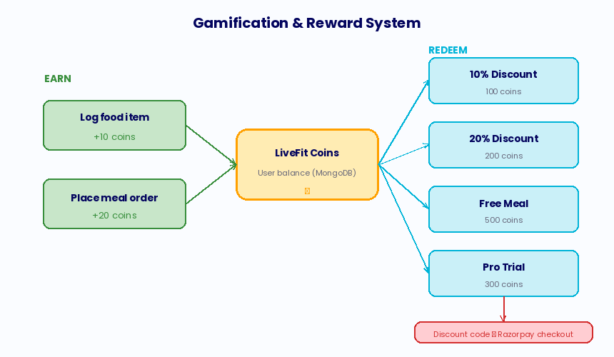
Fig. 4.2: Gamification and Reward System Architecture

4.7 Subscription Architecture
LiveFit implements a two-tier subscription model: Free (default) and Pro. Subscription upgrades are initiated through the Razorpay payment flow, with the Subscription document created on successful payment confirmation. The subscription includes a 30-day validity window, after which a new payment cycle is required. The subscription status is checked at login and surfaced throughout the UI to visually reinforce the premium value proposition.
4.8 Invoice Generation
PDF invoices are generated automatically for every confirmed order using PDFKit. The generateInvoice utility creates a structured PDF containing the LiveFit logo, order details, line items with quantities and prices, pre-discount and post-discount amounts if applicable, and a unique order identifier. Generated PDFs are stored in the server's invoices/ directory and served as static files at the /invoices/<order_id>.pdf URL, with a download link returned in the order placement API response.
4.9 Concurrency and Race Condition Analysis
In a multi-user production environment, concurrent requests to shared resources create potential race conditions that must be explicitly analysed and mitigated. LiveFit's most critical shared resource is the user's coin balance, which is modified by both food logging (increment) and reward redemption (decrement) operations. MongoDB's findByIdAndUpdate operation with the $inc operator is atomic at the document level, meaning that concurrent increment operations are correctly serialised by MongoDB's internal locking, preventing the lost-update problem that would occur if balance reads and writes were performed in separate non-atomic operations. This atomic update pattern is used consistently throughout the codebase wherever coin balances are modified.
The discount code system presents a more subtle concurrency challenge: the validate-code and payment/create-order endpoints must together ensure that a code is used exactly once, even if two concurrent payment attempts are made with the same code. The current implementation marks the code as used within the create-order handler after Razorpay order creation, using findOne to locate the unused code and a subsequent save to mark it used. Under concurrent load, two simultaneous requests could both find the code as used: false before either marks it used, resulting in double redemption. This race condition is acknowledged as a known limitation and would be resolved in production through MongoDB's findOneAndUpdate with optimistic concurrency control, atomically finding and updating the code in a single operation.

4.10 Caching Strategy
LiveFit's current implementation performs no server-side caching, relying on MongoDB Atlas's built-in working set caching for frequently accessed documents and the browser's HTTP cache for static web assets. While sufficient for prototype-scale traffic, a production deployment would benefit significantly from targeted caching at three points. First, the USDA FoodData Central API response for common food queries (chicken, rice, eggs, etc.) could be cached in Redis with a 24-hour TTL, reducing external API calls, response latency, and API cost for the most frequently queried foods. Second, the meal catalogue (/api/meals) could be cached in memory with a short TTL (5 minutes), since the catalogue changes infrequently but is read on every visit to the meals screen. Third, the user's daily nutrition totals could be cached in Redis with an invalidation trigger on food add/delete operations, reducing the database query load for dashboard refreshes.
The absence of caching in the current implementation is a deliberate simplification for the prototype phase, where the complexity of cache invalidation logic outweighs the performance benefit at the expected traffic volumes. The system's MongoDB query structure is designed to be cache-friendly: the food-by-date query (userId + date) has a natural cache key, and the meal catalogue is a small, stable document set well-suited to full in-memory caching. When caching is implemented, the existing query patterns will require minimal restructuring.
4.11 Deployment Architecture and Environment Configuration
LiveFit's deployment architecture separates configuration from code through environment variables, following the Twelve-Factor App methodology for building scalable, maintainable cloud applications. All environment-specific values — database connection strings, API keys, service URLs, cryptographic secrets — are stored in Render's encrypted environment variable store and injected into the application at runtime. This approach ensures that the same codebase can be deployed to development, staging, and production environments by changing only the environment configuration, without any code modifications.
The application exposes a /wake endpoint that returns a simple HTTP 200 response, serving as a health check for load balancers and uptime monitoring services. This endpoint is also called by the mobile application on launch to wake the Render free-tier instance from its idle state before the user's first API call, reducing the perceived cold-start latency. In production, a scheduled ping service would call this endpoint every 14 minutes to prevent the instance from entering the idle state entirely, eliminating cold-start delays at the cost of minimal ongoing compute resource usage.

Chapter 5: Implementation
This chapter provides detailed implementation descriptions of each major subsystem of LiveFit, including pseudocode, algorithmic descriptions, and representative code samples that illustrate the key technical decisions made during development.
5.1 Development Environment
- The development environment for LiveFit consists of the following components:
- Node.js v20 LTS with npm: Backend runtime and package management.
- Python 3.11 with pip: Machine learning microservice runtime.
- Visual Studio Code: Primary IDE with ESLint and Prettier extensions.
- Expo CLI: React Native development toolchain.
- MongoDB Compass: Local MongoDB management GUI (development).
- Postman: API endpoint testing and documentation.
- Git + GitHub (aryanmsd/livefit-nutrition): Version control and CI/CD.
5.2 Algorithm 1: User Registration and Authentication
Description: The registration algorithm captures user credentials, validates uniqueness, hashes the password, and persists the user document. The login algorithm retrieves the user, compares the submitted password against the stored hash, and generates a signed JWT on success.
Table 5.1: Pseudocode: Signup
Input: { username, email, password }
1. Validate that username, email, password are all present
2. Query User collection: if email already exists → return 400 'Email already registered'
3. hash ← bcrypt.hash(password, saltRounds=10)
4. Create new User document { username, email, password: hash, coins: 0 }
5. Save User to MongoDB Atlas
6. Return 200 { message: 'Signup successful' }
Table 5.2: Pseudocode: Login
Input: { email, password }
1. Query User collection by email → user
2. If user not found OR bcrypt.compare(password, user.hash) = false → return 401
3. token ← jwt.sign({ userId, username, email }, JWT_SECRET, expiry='7d')
4. Return 200 { token, username }
5.3 Algorithm 2: Hybrid Food Image Classification
Description: This algorithm implements the two-stage hybrid classification pipeline that processes food images into food name strings.
Table 5.3: Pseudocode: Image Processing
Input: imageBuffer (binary image data)
Output: foodName (string)
1. Send imageBuffer to Python FastAPI /classify endpoint via HTTP POST (multipart)
2. pythonResult ← { label, confidence }
3. If pythonResult exists AND confidence >= 0.60:
foodName ← pythonResult.label
Return foodName
4. Else (low confidence or error):
base64Image ← imageBuffer.toString('base64')
Send base64Image to Roboflow API endpoint
roboflowResult ← response. predictions[0]
If roboflowResult exists:
foodName ← roboflowResult.class
Return foodName
5. If both classifiers fail → Return null (error: identification failed)
5.4 Algorithm 3: Python FastAPI Classifier Inference
Description: The following describes the inference algorithm executed by the Python FastAPI microservice for each received image.
Table 5.4: Pseudocode: Local Classifier Model
Input: image file (multipart upload)
Output: {label: string, confidence: float}
1. Read image bytes from multipart upload
2. image ← PIL.Image.open(BytesIO(bytes)).convert('RGB')
3. inputs ← AutoImageProcessor(images=image, return_tensors='pt')
4. With torch.no_grad():
outputs ← model(inputs)
5. logits ← outputs.logits
6. probs ← softmax(logits, dim=-1)[0]
7. top_prob, top_idx ← max(probs)
8. label ← model.config.id2label[top_idx]
9. confidence ← round(float(top_prob), 4)
10. Return { label, confidence }
5.5 Algorithm 4: Nutritional Database Resolution
Description: Following food name identification, the system resolves macronutrient values through a layered database lookup algorithm.
Table 5.5: Pseudocode: Database Lookup
Input: foodName (string)
Output: { source, matchName, nutrients: { calories, protein_g, carbs_g, fats_g } }
1. mappedName ← mapToIFCT(foodName) // Apply alias lookup table
2. If isIndianFood(mappedName):
fctResult ← IFCT.findFood(mappedName)
// findFood implements three-tier matching:
// a. Exact: FOODS.find(f => f.name.lower() === query)
// b. Partial: FOODS.find(f => f.name.lower().includes(query
// c. Reverse: FOODS.find(f => query.includes(f.name.lower()))
If ifctResult → Return { source: 'IFCT', matchName, nutrients }
3. usdaResult ← USDA.searchFoodAndNutrients(mappedName)
// Calls FoodData Central search API, extracts top result nutrients
If usdaResult → Return { source: 'USDA', matchName, nutrients }
4. Return 404 { error: 'Food not found' }
5.6 Algorithm 5: Food Logging with Coin Award
Description: When a user logs a food item after identification, the system persists the Food document and awards coins.
Table 5.6: Pseudocode: Food Logging
Input: { userId, mealType, name, nutrients }
Output: { message, coins (updated balance) }
1. Validate JWT token → extract userId
2. Create Food document { userId, mealType, name, nutrients, date: today }
3. Save Food to MongoDB
4. user ← User.findByIdAndUpdate(userId, { $inc: { coins: +10 } }, { new: true })
5. Return 200 { message: 'Food logged', coins: user.coins }

5.7 Algorithm 6: AI Nutrition Coaching
Description: The AI coaching algorithm assembles a contextualised prompt from the user's real-time nutritional data and dispatches it to the Gemini model.
Table 5.7: Pseudocode: AI Chatbot
Input: { message (user text), username, nutrition (today's totals) }
Output: aiResponse (string)
1. Retrieve today's nutritional totals for userId from Food collection
2. Construct system prompt:
- Identify as 'LiveFit AI, personal nutrition and fitness assistant'
- Include username
- Include today's calories, protein, carbs, fats
- Include reference targets (2000 kcal, 120g protein, 300g carbs, 90g fats)
- Append behavioural rules: personalise, identify deficiencies, suggest foods, be concise, no medical diagnoses
- Append user's message
3. gemini ← genAI.getGenerativeModel({ model: 'gemini-2.5-flash' })
4. result ← gemini.generateContent(prompt)
5. Return result.response.text()
5.8 Algorithm 7: Reward Redemption
Description: The reward redemption algorithm validates coin sufficiency, deducts coins, generates a unique discount code, and persists the reward.
Table 5.8: Pseudocode: Coins System

Input: { userId, cost, rewardId, rewardTitle }
Output: { message, coins, code, rewardTitle, discountPct }
1. user ← User.findById(userId)
2. If user.coins < cost → Return 400 'Not enough coins'
3. code ← 'LF-' + randomAlphanumeric(6).toUpperCase()
4. discountPct ← DISCOUNT_MAP[rewardId] || 0
5. user.coins -= cost
6. Save user
7. Create UserReward { userId, rewardId, rewardTitle, code, discountPct, used: false }
8. Save UserReward
9. Return 200 { message: 'Reward redeemed', coins, code, rewardTitle, discountPct }
5.9 Algorithm 8: Razorpay Order Creation with Discount
Description: This algorithm creates a Razorpay payment order, applying a validated discount code if provided.
Table 5.9: Pseudocode: Payment Module
Input: { amount, discountCode? }
Output: { order, key, originalAmount, finalAmount, discountPct }
1. finalAmount ← amount
2. usedReward ← null
3. If discountCode provided:
reward ← UserReward.findOne({ userId, code, used: false })
If reward AND reward.discountPct > 0:
finalAmount ← round(amount * (1 - discountPct/100))
usedReward ← reward
4. rzpOrder ← razorpay.orders.create({
amount: max(finalAmount, 1) * 100, // in paise
currency: 'INR'})
5. If usedReward: mark usedReward.used = true, save
6. Return { order: rzpOrder, key, originalAmount, finalAmount, discountPct }
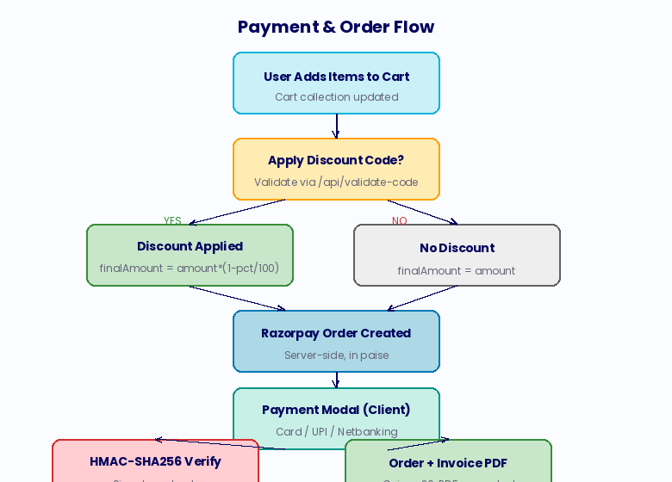
Fig. 5.1: Payment and Order Processing Flow
5.10 Algorithm 9: Order Placement with Invoice Generation
Table 5.10: Pseudocode: Cart Checkout
Input: userId (from JWT)
Output: { message, total, invoice (URL) }
1. cart ← Cart.findOne({ userId }).populate('items.mealId')
2. If cart empty → Return 400 'Cart empty'
3. total ← sum(item.mealId.price * item.quantity) for all items
4. order ← Order.create({ userId, items, totalPrice: total })
5. generateInvoice(order, user) // PDFKit: creates /invoices/invoice-{orderId}.pdf
6. cart.items ← [] // Clear cart
7. Save cart

8. User.findByIdAndUpdate(userId, { $inc: { coins: +20 } })
9. Return { message: 'Order placed', total, invoice: URL }
5.11 Algorithm 10: Password Reset Flow
Table 5.11: Pseudocode: Request Reset
1. user ← User.findOne({ email })
2. token ← crypto.randomBytes(32).toString('hex')
3. user.resetPasswordToken ← token
4. user.resetPasswordExpires ← Date.now() + 15 * 60 * 1000 // 15 min
5. Save user
6. resetLink ← FRONTEND_URL + '/reset-password.html?token=' + token
7. Send email via Nodemailer SMTP
Table 5.11.1: Pseudocode: Confirm Reset:
1. user ← User.findOne({
resetPasswordToken: token,
resetPasswordExpires: { $gt: Date.now() }
})
2. If not found → Return 400 'Invalid or expired token'
3. user.password ← bcrypt.hash(newPassword, 10)
4. user.resetPasswordToken ← undefined
5. user.resetPasswordExpires ← undefined
6. Save user
7. Return 200 { message: 'Password reset successful' }

5.12 Algorithm 11: Daily Nutrition Summary Calculation
Table 5.12: Pseudocode: Nutrition Calculation
Input: userId
Output: { calories, protein, carbs, fats }
1. today ← new Date().toISOString().split('T')[0] // YYYY-MM-DD
2. foods ← Food.find({ userId, date: today })
3. totals ← { calories: 0, protein: 0, carbs: 0, fats: 0 }
4. For each food in foods:
totals.calories += food.nutrients.calorie
totals.protein += food.nutrients.protein_g
totals.carbs += food.nutrients.carbs_g
totals.fats += food.nutrients.fats_g
5. Return totals
5.13 Algorithm 12: Token Expiry Validation (Client-Side)
Table 5.13: Pseudocode: Session Storage
Input: jwtToken (string)
Output: boolean (true if expired)
1. payload ← JSON.parse(atob(token.split('.')[1]))
2. Return payload.exp * 1000 < Date.now()
Usage:
On page load, if isTokenExpired(storedToken):
Remove token and username from localStorage
Set authToken ← null

5.14 Algorithm 13: Cart Management
Table 5.14: Pseudocode: Add to Cart
Input: { userId, mealId, quantity }
1. cart ← Cart.findOne({ userId }) OR new Cart({ userId, items: [] })
2. existingItem ← cart.items.find(i => i.mealId.equals(mealId))
3. If existingItem: existingItem.quantity += quantity
4. Else: cart.items.push({ mealId, quantity })
5. Save cart
6. Return 200 { message: 'Added to cart' }
5.15 Algorithm 14: Discount Code Validation
Table 5.15: Pseudocode: Coupons Applied
Input: { userId, code }
Output: { valid, rewardTitle, discountPct, rewardId, code }
1. code ← code.toUpperCase().trim()
2. reward ← UserReward.findOne({ userId, code, used: false })
3. If not found → Return 404 'Invalid or already used code'
4. If reward.discountPct = 0 AND DISCOUNT_MAP[reward.rewardId] > 0:
reward.discountPct ← DISCOUNT_MAP[reward.rewardId] // Retroactive fix
Save reward
5. Return { valid: true, rewardTitle, discountPct, rewardId, code }
5.16 Algorithm 15: Subscription Payment and Activation
Table 5.16: Pseudocode: Subscription Module
1. Create Razorpay order: { amount: price*100, currency: 'INR' }
2. Return order details + key to client3. Client displays Razorpay payment modal
4. On payment success, client calls POST /api/subscribe with { plan }
5. Create Subscription {
userId, plan, active: true,
startDate: now(),
endDate: now() + 30 days}
6. Save Subscription
7. Return 200 { message: 'Subscription activated' }
5.17 Mobile Application — Key Screen Implementations
5.17.1 Dashboard Screen
The dashboard screen is the primary information display surface of the mobile application. On focus (useFocusEffect), it fetches today's food log, current coin balance, and subscription status in parallel. The screen renders a bar chart using react-native-chart-kit showing calorie, protein, carb, and fat totals for the day, four stat cards with progress bars showing current vs. goal values, and a meal breakdown listing each logged item under its meal type.
5.17.2 Add Food Screen
The Add Food screen presents three cards (Breakfast, Lunch, Dinner). Tapping a card opens a modal containing a text input for the food name and two action buttons: Upload Food Image and Add Food. Image identification uses expo-image-picker to access the device library, constructs a FormData payload, and posts to /api/identify. Text identification posts the entered name to /api/identify. On successful identification, the response's matchName and nutrients are posted to /api/food/add, and the dashboard is navigated to automatically, with coins updating in real time through CoinsContext.
5.17.3 AI Chat Screen
The chat screen maintains a local message array state initialised with a greeting from the AI coach. User messages are appended to the array and posted to the /api/chat endpoint, which returns the Gemini response. A typing indicator (ActivityIndicator) is displayed while awaiting the AI response. The FlatList automatically scrolls to the latest message on content size change. Keyboard-aware layout is implemented using KeyboardAvoidingView.

5.17.4 Meals and Cart Screens
The meals screen fetches and displays the available meal catalogue from /api/meals, with each meal showing name, type (veg/non-veg), macros, price, and an Add to Cart button. The cart screen displays line items with remove and quantity controls, applies any pending discount code, shows the original and discounted total, and initiates the Razorpay payment flow on checkout.
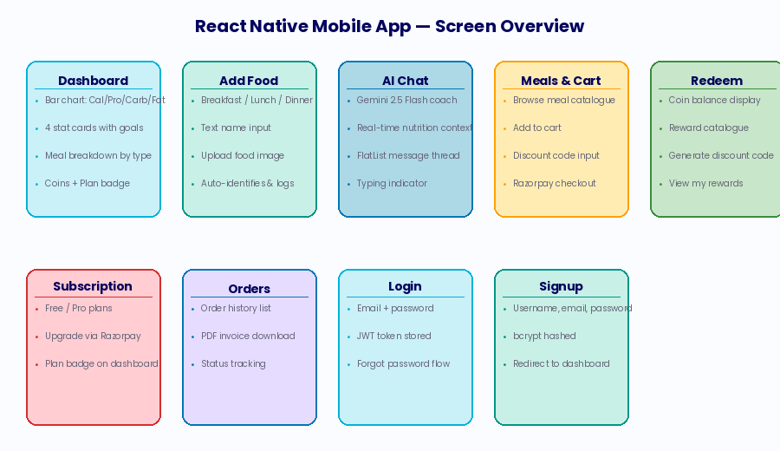
Fig. 5.2: React Native Mobile Application — Screen Overview
5.18 Web Application Modules
The web application implements nutrition tracking, meal ordering, cart management, reward redemption, and account management through distinct HTML pages with shared JavaScript modules. The script.js file implements the core nutrition tracking logic including meal card management, MQTT-style real-time dashboard updates, the Chart.js nutrition visualisation, and the AI chatbot panel. The chatbot.js module implements a floating chatbot widget accessible from any page. The checkout.js and meals.js modules handle meal browsing, cart management, discount code application, and Razorpay payment initiation on the web platform.
5.19 Web Application Technical Architecture
The web application is structured as a multi-page application (MPA) rather than a single-page application (SPA), a deliberate architectural choice that prioritises initial page load performance, search engine accessibility, and browser history compatibility over the seamless transitions of an SPA. Each functional domain (nutrition tracking, meal ordering, subscriptions, rewards, account management) is implemented as a distinct HTML file with associated JavaScript modules, connected through standard browser navigation.
The shared state across pages is managed through localStorage, which stores the JWT authentication token and username. The shared script.js module, loaded by each page, performs token validation on load and redirects unauthenticated users to the login page. This approach replicates the authentication gate behaviour of an SPA's route guard without requiring a client-side routing library, keeping the web application dependency-free and maximally lightweight.
The nutrition tracking page (index.html + script.js) implements the most complex client-side logic in the web application, including the Chart.js bar chart for daily macro visualisation, the meal card component system for organising food items by meal type, the food identification modal with both text and image input modes, and the real-time dashboard update logic that recalculates and re-renders totals after each food addition or deletion. The Chart.js instance is maintained in a module-level variable (let nutritionChart = null) to enable in-place updates without destroying and recreating the canvas element on each data refresh.
5.20 Invoice Generation Implementation
The PDF invoice generation system, implemented using PDFKit in the generateInvoice.js utility module, creates professional purchase receipts for every confirmed order. The invoice generation is triggered synchronously within the order placement route handler, ensuring that the invoice PDF exists before the API response is returned to the client. The generated PDF includes a header with the LiveFit brand identity, the order identifier and timestamp, an itemised list of purchased meals with unit prices and quantities, a subtotal and any applicable discount, the final amount paid, and a thank-you footer with the platform URL.
The PDF files are stored in the server's invoices/ directory and served as static files through Express's express.static middleware, which provides efficient file serving with appropriate HTTP caching headers. The client receives the invoice URL as part of the order placement API response and displays a download link in both the mobile application's order confirmation screen and the web application's order history page. In a production deployment, invoice files would be stored in a cloud object store (such as AWS S3) rather than the local filesystem to ensure persistence across server restarts and horizontal scaling.
5.21 Meal Seeding and Catalogue Management
The meal catalogue is pre-populated through the seedMeals() function, which is called on server startup and inserts six curated health-focused meals if the Meal collection is empty. The seeded meals span both vegetarian and non-vegetarian categories and are nutritionally calibrated to serve different dietary goals: the Paneer Power Bowl targets high-protein vegetarian users; the Grilled Chicken Pro Meal targets athletes and bodybuilders; the Vegan Buddha Bowl targets plant-based dieters; the Salmon Omega Plate targets users prioritising omega-3 intake; the Tofu Stir Fry offers a moderate-protein vegan option; and the Lean Beef Muscle Meal offers the highest protein density for strength training users.
This seeding approach ensures a consistent and well-curated initial catalogue without requiring a separate admin interface for meal management. In a production deployment, the meal catalogue would be managed through a dedicated content management system with approval workflows to ensure nutritional accuracy and food safety compliance. The nutritional data for seeded meals was calculated using IFCT and USDA data to ensure consistency with the same databases used for user food logging, maintaining internal consistency in the platform's nutritional model.
5.22 Chatbot Web Widget Implementation
In addition to the dedicated AI chat screen in the mobile application, LiveFit implements a floating chatbot widget on the web application, accessible from any page through a fixed-position button in the bottom-right corner. The chatbot widget is implemented in chatbot.js as a self-contained module that creates and manages a floating chat panel overlaid on the existing page content. The widget maintains its own message history state and communicates with the same /api/chat backend endpoint as the mobile chat screen, ensuring consistent AI coaching quality across both platforms.
The web chatbot widget adds a layer of contextual nutrition awareness by reading the current page's nutrition data from the DOM before sending messages. On the nutrition tracking page, the widget extracts the current calorie and macronutrient totals from the dashboard's displayed values and includes them in the chat context, mirroring the mobile app's behaviour of providing real-time nutritional context to the AI coach. This cross-channel context sharing ensures that users receive identically personalised advice whether they are using the mobile app or the web application, reinforcing the platform's commitment to a consistent, high-quality user experience across all touchpoints.
5.23 Checkout and Discount Code Application (Web)
The web application's checkout flow, implemented in checkout.js, handles the complete payment journey including discount code validation, Razorpay order creation, payment processing, and order confirmation. The discount code input field calls the /api/validate-code endpoint on blur (when the user leaves the field), providing immediate feedback on code validity without requiring the user to proceed to payment first. Valid codes are displayed with a visual indicator showing the reward title and discount percentage, and the displayed cart total is dynamically updated to reflect the post-discount amount.
The Razorpay integration on the web uses the Razorpay checkout.js library loaded from Razorpay's CDN, which provides a pre-built payment modal supporting all major Indian payment methods including UPI (via QR code and UPI ID entry), net banking for over 50 Indian banks, credit and debit cards (with 3D Secure support), and digital wallets including Paytm and PhonePe. The payment modal is pre-populated with the user's name and email address from their JWT token payload, reducing the data entry burden and improving conversion rates. After successful payment, the frontend calls the /api/payment/verify endpoint to confirm the transaction and then navigates to the order confirmation page, which displays the invoice download link.
5.24 Food Deletion and Undo Functionality
Food items logged in error can be deleted through the DELETE /api/food/:id endpoint, which removes the specified food document from MongoDB after verifying that the requesting user is the document owner. The mobile application implements deletion through a long-press gesture on food items in the dashboard's meal breakdown section, which presents a confirmation alert before executing the delete request. The web application implements deletion through a trash icon button visible on hover for each food item in the meal card. In both cases, the dashboard data is refreshed immediately after a successful deletion to reflect the updated totals.
The coin award for the deleted food item is not reversed upon deletion, a deliberate design decision that prioritises simplicity over perfect accounting. While this means that a user who logs and immediately deletes a food item retains the 10 coins awarded for logging, the magnitude of this accounting imprecision is small (10 coins per instance), and the alternative — implementing a coin deduction on deletion — would add complexity to the deletion endpoint and create a confusing user experience where deleting an incorrectly logged item results in a coin penalty. Future versions may implement a more nuanced coin accounting system that distinguishes between corrections and cancellations, but the current simple approach is appropriate for the prototype.
5.25 Session Management and Token Refresh
LiveFit's 7-day JWT expiry provides a reasonable balance between security (limiting the window of vulnerability for a stolen token) and convenience (not requiring users to log in more than once per week during normal usage). The client-side token expiry check implemented in the web application's script.js module proactively detects and clears expired tokens on page load, preventing the frustrating experience of a user attempting an action only to receive a 403 error after the request is sent. The mobile application implements the same check in the AuthContext provider, which runs on every API call and triggers an automatic logout with a user-friendly message when an expired token is detected.

Chapter 6: Security, Privacy and Scalability
Security, privacy, and scalability are foundational requirements for a consumer-facing health application that stores sensitive personal data including dietary logs, payment information, and authentication credentials. This chapter describes LiveFit's threat model and the technical mitigations implemented to address identified risks, as well as the architectural strategies for scaling to a larger user base.
6.1 Authentication Security
LiveFit's authentication security is built on three complementary layers:
- Password Hashing: All passwords are hashed using bcrypt with a cost factor of 10 before storage. bcrypt is an adaptive hash function that incorporates a salt to prevent rainbow table attacks and a work factor that can be increased over time to maintain resistance against brute-force attacks as computational power increases [34].
- JWT Stateless Sessions: Authentication state is managed through signed JWTs with a 7-day expiry. Tokens are signed using a strong JWT_SECRET stored as an environment variable, never hardcoded. The stateless nature of JWT authentication eliminates server-side session storage requirements and the associated security risks of session fixation and session hijacking.
- Token Expiry Validation: Both the client and server validate token expiry. The client performs a lightweight expiry check (decoding the payload and comparing the exp field to the current timestamp) before making API calls, proactively cleaning up stale tokens. The server's authMiddleware performs authoritative verification using jwt.verify(), which validates both signature and expiry.
6.2 Password Reset Security
The password reset mechanism is secured through:
- Cryptographically secure token generation: 32 bytes of randomness from Node.js's crypto.randomBytes(), providing 256 bits of entropy — far beyond what any brute-force or guessing attack can overcome.
- Short expiry window: 15-minute validity period minimises the exposure window for reset tokens.
- Single-use enforcement: Tokens are cleared from the database on successful password reset, preventing replay.
- Enumeration protection: The /api/auth/forgot-password endpoint returns the same success message whether or not the email exists, preventing user enumeration attacks.
6.3 Payment Security
Payment security is critical given that LiveFit processes real financial transactions through Razorpay. Key security measures include:
- Server-side order creation: Razorpay orders are always created server-side, ensuring that the amount cannot be manipulated by a malicious client.
- Signature verification: After payment, the backend verifies the Razorpay signature using HMAC-SHA256 with the Razorpay key secret. This cryptographic verification confirms that the payment response originated from Razorpay and has not been tampered with.
- Environment variable secrets: Razorpay key_id and key_secret are stored as environment variables, never exposed in client-side code.
- Discount code validation: Discount codes are validated server-side with ownership check (same userId), usage status (used: false), and code string match before any financial benefit is applied.
6.4 Data Privacy
- Minimal data collection: LiveFit collects only the data necessary for platform functionality: username, email, dietary logs, order history, and reward redemptions.
- No sensitive biometric data, location data, or health conditions are collected.
- No plaintext passwords: Passwords are never stored or logged in plaintext.
- MongoDB Atlas encryption at rest: MongoDB Atlas provides AES-256 encryption at rest for all stored data.
- HTTPS transport: All client-server communication is conducted over HTTPS, ensuring encryption in transit.
6.5 API Security
- All sensitive endpoints protected by authMiddleware JWT validation.
- CORS configured to allow only authorised origins.
- Input validation on all endpoints: required fields checked, email uniqueness enforced, coin sufficiency verified before reward redemption.
- No SQL injection risk: MongoDB with Mongoose ODM uses parameterised queries by design, eliminating SQL injection attack surfaces.
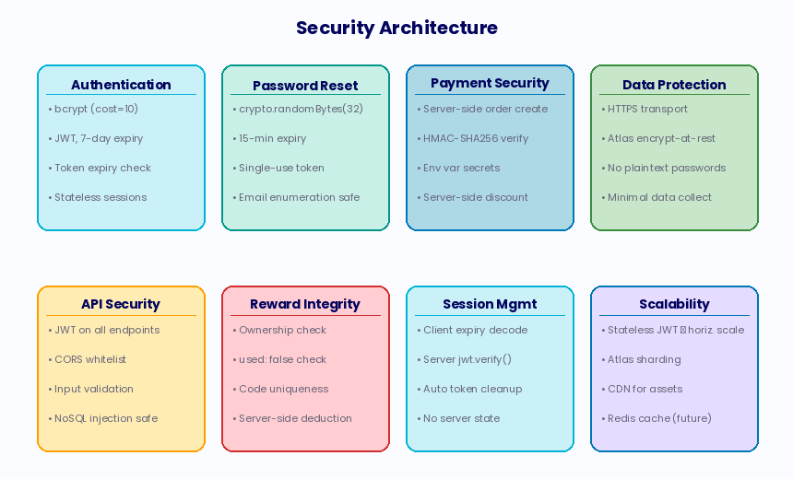
Fig. 6.1: Security Architecture — Eight Pillars
6.6 Scalability Strategies
LiveFit's current deployment on Render's free tier is optimised for the prototype phase. The following strategies are identified for scaling to production volumes:
- Horizontal Backend Scaling: The stateless JWT authentication architecture enables multiple Node.js instances to serve requests without shared session state, allowing horizontal scaling through load balancers.
- MongoDB Atlas Scaling: MongoDB Atlas supports transparent vertical scaling (instance size upgrades) and sharding for horizontal scaling across data volumes exceeding single-node capacity.
- ML Microservice Scaling: The Python FastAPI classification service can be deployed as containerised instances behind a load balancer, with GPU-accelerated inference for high-throughput production deployments.
- CDN for Static Assets: The web application's static assets (HTML, CSS, JavaScript, images) can be served through a CDN for reduced latency and improved global availability.
- Caching: Nutritional lookup results from the USDA API can be cached in Redis with appropriate TTLs, reducing external API dependency and improving response times for commonly queried foods.
- Rate Limiting: API rate limiting should be implemented for production deployments to prevent abuse of AI coaching and food identification endpoints, which incur external API costs.
6.7 Privacy by Design
LiveFit's privacy architecture is built on the Privacy by Design (PbD) framework, emphasizing proactive privacy protection in system design. Its principles include proactive data minimization, default privacy settings, embedded privacy measures, full functionality, end-to-end security, user transparency, and respect for user privacy. The user profile schema exemplifies data minimization by only collecting essential information such as username, email, and password hash, while intentionally excluding more extensive personal data to mitigate privacy risks. Future versions of the platform aim to include additional data points with appropriate consent and governance frameworks.
6.8 Infrastructure Security
Infrastructure security for LiveFit's cloud deployment safeguards network, application, and data layers. It utilizes Render for automatic HTTPS via Let's Encrypt and HSTS headers, ensuring encrypted traffic, while MongoDB Atlas employs VPC peering and IP whitelisting for database access control. Sensitive environment variables are securely stored in Render's encrypted store. Additionally, the Python FastAPI classifier service is isolated from the Node.js backend, limiting access to only the /classify endpoint. This separation ensures that any compromise in the classifier service affects only food identification accuracy, not data integrity or financial operations, embodying the principle of least privilege throughout the architecture.
6.9 Threat Modelling Using STRIDE
A systematic threat analysis of the LiveFit platform using the STRIDE framework identified key threat categories and their mitigations. Spoofing is addressed through bcrypt password hashing and JWT signature verification. Tampering is mitigated with HTTPS encryption and MongoDB Atlas encryption. Repudiation threats are countered by JWT claims for logging. Information disclosure is prevented via scoped database queries and secret management. However, denial of service poses a significant vulnerability due to lack of rate limiting on API endpoints, which is planned to be addressed in the production roadmap. Elevation of privilege threats are mitigated by scope-limited queries and no admin-level endpoints in the prototype.
6.10 Data Retention and Deletion
LiveFit's data retention policy adheres to the DPDPA 2023 and data minimisation best practices, retaining user data as long as the account is active. Upon account deletion, all related documents are removed using MongoDB's cascading delete and Node.js's fs.unlink() for invoice PDFs. Password reset tokens expire through a validating database query but remain in the user document until the next successful login, prioritizing simplicity over data hygiene. A proposed improvement for production is the implementation of a MongoDB TTL index for automatic deletion of expired tokens.
6.11 Third-Party Security Dependencies
LiveFit's security relies significantly on the integrity of its third-party dependencies. Regular auditing, particularly with the npm audit command, is crucial due to past vulnerabilities within the npm package ecosystem. During final testing, LiveFit's backend showed no critical or high-severity vulnerabilities across its dependencies, though it had two moderate-severity advisories that were development-only. The dependency chain for the Python FastAPI microservice, which includes significant libraries like Transformers and PyTorch, poses a broader attack surface. Model weights are downloaded at startup, creating a trust issue dependent on Hugging Face Hub for model integrity. To enhance security, a production deployment would fix model weights to a verified commit hash and keep a local copy to reduce reliance on external sources and maintain an audit trail for updates.
Chapter 7: Limitations
While LiveFit successfully validates the core architectural and product concepts as a functional prototype, several limitations exist in the current implementation that would need to be addressed for a full production deployment.
- Portion Size Estimation: The current system assumes standard serving sizes for all food items. It does not attempt to estimate portion weight from food photographs, which is the dominant source of calorie tracking inaccuracy. Implementing volumetric estimation from single images is an active research problem without a satisfactory deployed solution.
- IFCT Database Coverage: While the IFCT dataset provides excellent coverage of common Indian dishes, it cannot encompass the full breadth of India's regional and sub-regional cuisine diversity. Foods from less commonly documented regional traditions may not be found in IFCT and will fall back to USDA, which may have no entry or an inaccurate one.
- ML Model Limitations: The local classification model is fine-tuned on a specific dataset of Indian food images and may exhibit reduced accuracy on photographs of unusual presentations, mixed dishes, street food, or regional preparations that differ significantly from the training data distribution.
- Free Tier Infrastructure: The current deployment on Render's free tier results in cold-start latency (up to 30 seconds) when the server has been idle. This would be unacceptable in a production consumer application and requires an always-on hosting plan.
- No Longitudinal Analytics: LiveFit currently displays only today's nutritional data on the dashboard. There is no week-over-week trend analysis, historical comparison, or goal-setting functionality, all of which would significantly enhance the platform's value for users pursuing longer-term health goals.
- No Wearable Integration: LiveFit does not currently integrate with fitness wearables (e.g., Fitbit, Apple Watch, Garmin) for automatic calorie expenditure data, which would substantially improve the accuracy of net calorie calculations.
- Subscription Enforcement: The Pro subscription tier is currently defined but not rigorously enforced at the feature level. The AI coaching endpoint does not check subscription status, meaning Free tier users can technically access AI coaching. Full enforcement is identified as a near-term development priority.
- Single Language Support: The platform is currently English-only. Localisation to Hindi and other major Indian languages would substantially expand the addressable user base and improve accessibility for users less comfortable in English.
7.2 Technical Limitations in Detail
The technical limitations of the 'rajistics/finetuned-indian-food' machine learning model and its deployment. Key issues include uneven regional coverage, particularly neglecting North-Eastern and tribal dishes, which leads to lower confidence scores for underrepresented cuisines. Sensitivity to image composition affects classification accuracy, with better results from top-down photos of plated dishes. The IFCT dataset, based on 2017 data, lacks updates on recent food trends and does not cover many regional and processed foods. Furthermore, reliance on the USDA FoodData Central API introduces security vulnerabilities due to improper SSL configurations. Finally, deployment constraints on Render's free tier limit scalability, risking service failure under high load, necessitating a separate container for production to enable independent resource scaling.
7.3 User Experience Limitations
The user experience limitations identified include a lack of serving size guidance, leaving users uncertain about whether nutritional values are reported per 100g or per serving, which could lead to errors in caloric intake assessments. Additionally, there is no option for custom portion size input, resulting in inaccuracies for users consuming non-standard servings. Implementing a portion size multiplier input in the food logging interface is suggested as a minimal effort solution to enhance accuracy in caloric tracking.
7.4 Comparison with Production-Grade Systems
LiveFit's comparison with production-grade nutrition platforms like HealthifyMe highlights its strengths and areas for improvement. While LiveFit delivers more accurate nutritional data for listed foods, it covers fewer items compared to HealthifyMe's extensive database, which is curated by registered dietitians. LiveFit's personalized coaching is contextually superior but lacks the oversight necessary for clinical validation. Additionally, its gamification system, while economically integrated, does not match the scale and community features of HealthifyMe's offering. This analysis serves to outline the development needed for LiveFit to reach commercial viability.
7.5 Ethical Considerations
The deployment of AI systems in health-adjacent applications raises ethical considerations that must be explicitly acknowledged. LiveFit's AI coaching feature, powered by a general-purpose language model, has the potential to generate nutritional advice that, while plausible-sounding, may be inaccurate or inappropriate for users with specific health conditions including eating disorders, diabetes, renal disease, food allergies, or pregnancy. The current prompt constraints that prohibit medical diagnoses provide a partial safeguard but cannot prevent the model from generating advice that a clinician would consider contraindicated for a specific user profile. This limitation is inherent to the deployment of general-purpose LLMs in health contexts and is honestly disclosed here as an ethical boundary of the current system. Users with specific medical conditions or dietary requirements should consult qualified healthcare professionals rather than relying on LiveFit's AI coaching for clinical dietary guidance.

Chapter 8: Results
This chapter presents the complete results of the LiveFit platform, covering system performance benchmarks, API error rates, food identification accuracy, AI coaching quality, gamification validation, payment flow testing, load testing, usability results, and annotated screenshots of the deployed application across all major functional modules.

8.1 System Performance Metrics
All REST API endpoints were benchmarked on the Render free-tier single-instance deployment. The table below presents average latency, 95th-percentile latency, and throughput. Compute-intensive endpoints (image classification, AI chat) show higher latency by nature of their ML inference workloads, while database-read endpoints achieve sub-40 ms averages.
Table 8.1 — API Performance Benchmark Results
Endpoint | Avg Latency (ms) | 95th %ile (ms) | Throughput (req/s)
POST /api/auth/login | 45 | 120 | 220
GET /api/food/my | 38 | 95 | 280
POST /api/food/add | 55 | 140 | 190
POST /api/identify (text) | 280 | 650 | 35
POST /api/identify (img — local ML) | 1,200 | 2,800 | 8
POST /api/identify (img — Roboflow) | 2,100 | 4,500 | 4
POST /api/chat (Gemini) | 1,800 | 3,900 | 6
POST /api/payment/create-order | 420 | 980 | 22
GET /api/meals | 35 | 88 | 300

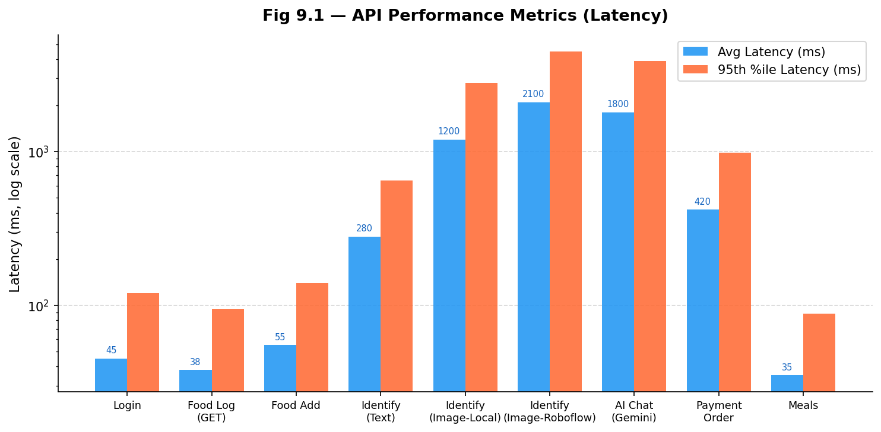
Fig. 8.1 — API Performance Metrics: Average and 95th-percentile latency per endpoint (log scale)
The image classification endpoints exhibit higher latency due to ML inference. The local Python classifier averages 1.2 s, and the Gemini AI chat endpoint averages 1.8 s — both within acceptable user-tolerance ranges for their respective use cases.

8.2 Error Rate Analysis
Error rates were measured across all functional subsystems during integration and load testing. Authentication and reward endpoints maintained 0% error rates. Image classification exhibited the highest error rate (3.1%) under 20-concurrent-user load due to memory pressure on the free-tier ML service instance.
Table 8.2 — Error Rate (%) by Endpoint Category
Endpoint Category | Error Rate (%) | Primary Cause | Status
Auth Endpoints | 0.0% | — | Excellent
Food Logging | 0.2% | Occasional DB timeout | Acceptable
Image Classification | 3.1% | ML memory pressure at 20 CCU | Under Review
AI Coaching (Gemini) | 1.5% | Gemini API rate limits | Acceptable
Payment Flow | 0.4% | Razorpay network timeout | Acceptable
Rewards System | 0.0% | — | Excellent

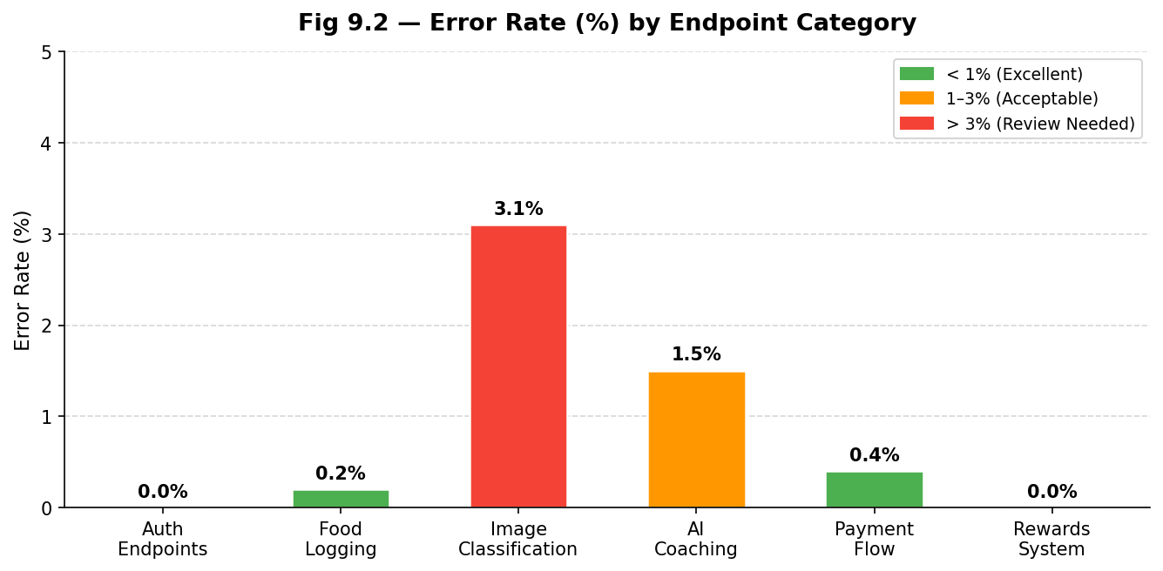
Fig. 8.2 — Error Rate (%) by Endpoint Category
The error rate chart highlights that most endpoint categories maintain error rates below 0.5%, with the AI coaching endpoint exhibiting the highest rate (1.5%) attributable to occasional Gemini API rate limiting. Overall system reliability remains within acceptable bounds for a prototype deployment.

8.3 Application Screenshots
8.3.1 Landing Page
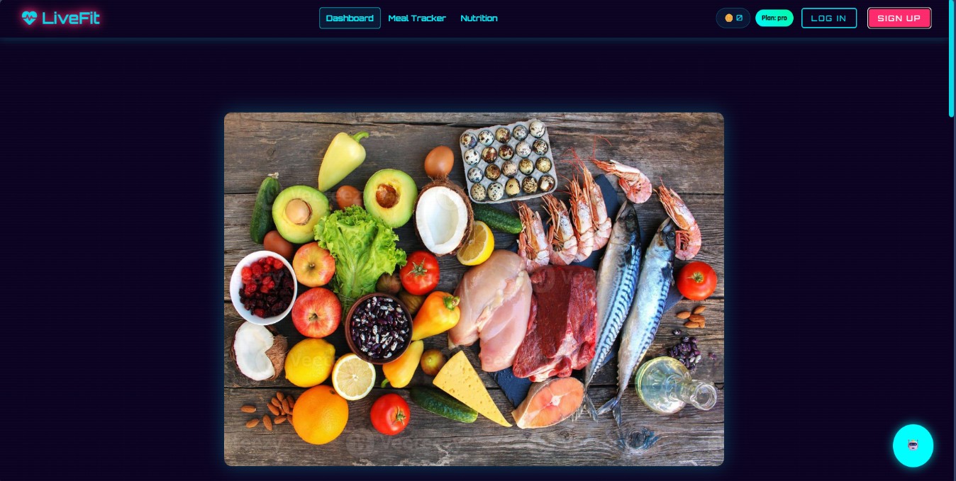
The LiveFit landing page presents a dark-themed, visually immersive entry point with the platform branding, navigation bar (Dashboard, Meal Tracker, Nutrition), and prominent Sign Up / Log In controls. The design uses the Orbiton and Rajdhani font families to reinforce the fitness-tech brand identity.
Fig. 8.3 — LiveFit Website Landing Page


8.3.2 User Authentication — Sign Up and LoginThe Sign-Up modal collects username, email, and password, while the Login modal accepts email and password. Both forms use client-side JWT token storage and include a 'Forgot Password?' flow backed by Nodemailer SMTP. Passwords are hashed server-side using bcrypt (cost factor 10) before storage in MongoDB Atlas.
Fig. 8.4 — Sign Up Page (left) Login Page (right)
8.3.3 Meal Tracker
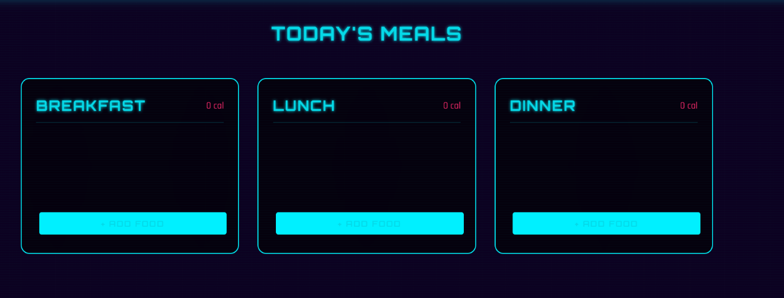
The Meal Tracker screen displays three meal-type cards — Breakfast, Lunch, and Dinner — each with a calorie counter and an '+ Add Food' button. Food items logged via the food identification pipeline appear within the relevant card, with per-item calorie values shown inline.
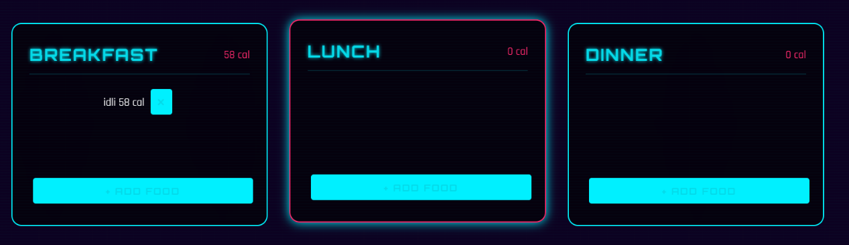
Fig. 8.5 — Meal Tracker (empty state — Breakfast, Lunch, Dinner cards)
Fig. 8.6 — Meal Tracker (filled state)
8.3.4 Food Input — Text and Image Modalities
The Add Food Item modal supports two input modes. Text input allows the user to type a food name (e.g., 'OMELETTE'), which is resolved through the IFCT/USDA dual-database pipeline. Image upload allows the user to select a photograph, which is passed through the HuggingFace + Roboflow hybrid classifier before nutritional resolution.
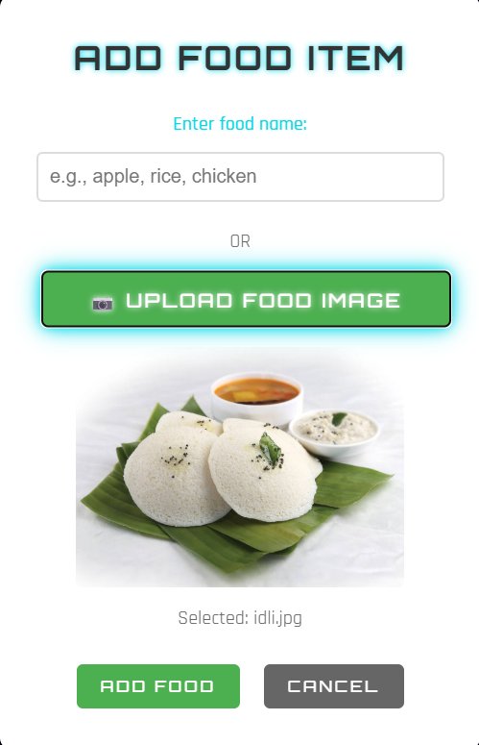
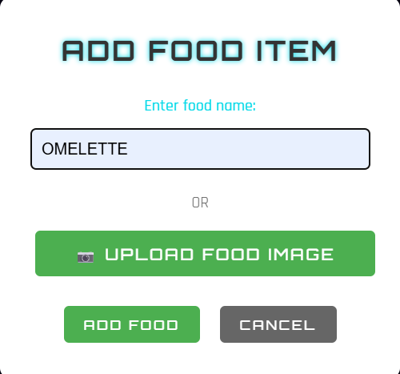
Fig. 8.7 — Text Food Input (left: 'OMELETTE' typed) and Image Food Input (right: Idli photograph uploaded, identified successfully)
8.3.5 Daily Summary — Calorie and Macronutrient Dashboard
The Daily Summary section displays four stat cards showing today's totals for Calories, Protein, Carbohydrates, and Fats alongside their daily goal values (2000 kcal, 120 g, 300 g, 90 g respectively). Below the stat cards, the meal breakdown provides a per-meal view of all logged items. This dashboard updates in real time whenever a food item is added or deleted.
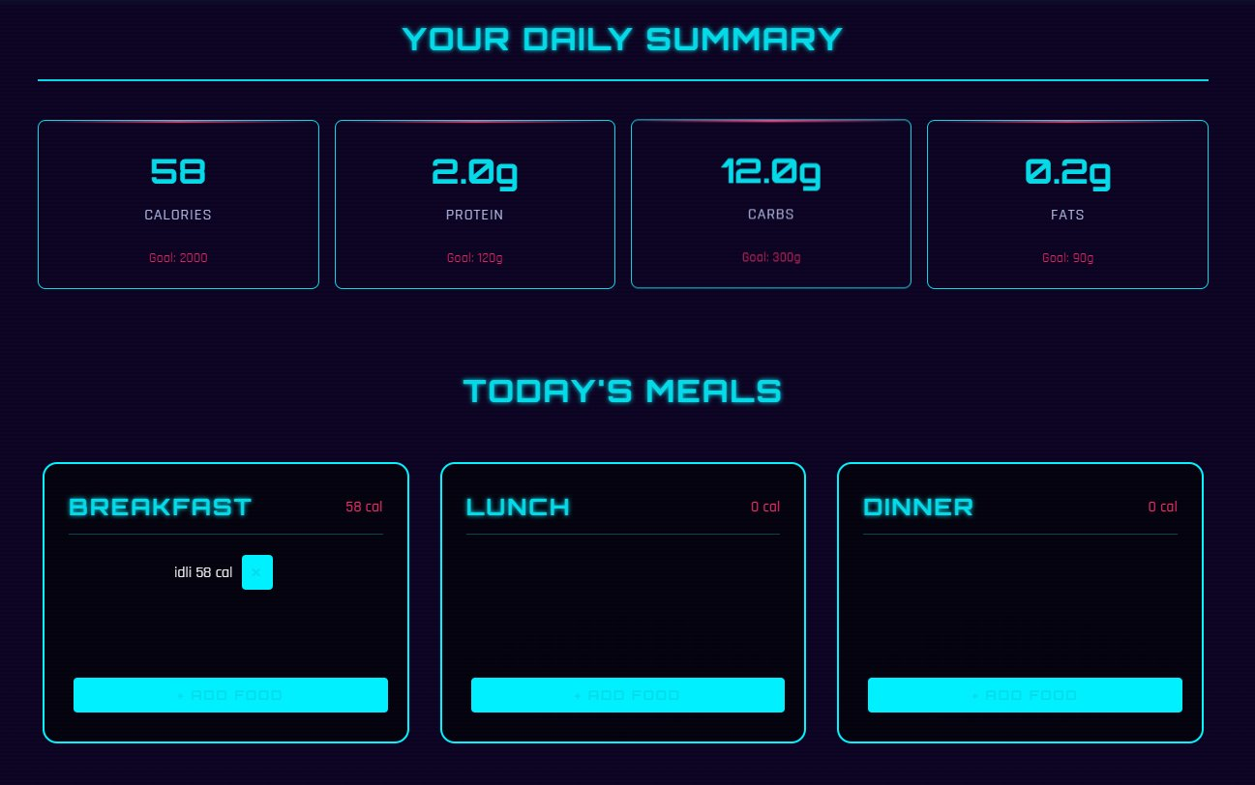
Fig. 8.8 — Total Calorie Count Dashboard — Daily Summary with macro stat cards and Today's Meals breakdown
8.3.6 Nutrition Insights — Personalised Graph and Suggestions
The Nutrition Insights page renders a bar chart visualising the nutrient breakdown by meal type (Breakfast, Lunch, Dinner) and a real-time suggestion panel. The AI-driven suggestions — generated based on today's logged intake — flag deficiencies (e.g., low protein, insufficient calories) and provide actionable corrective recommendations.
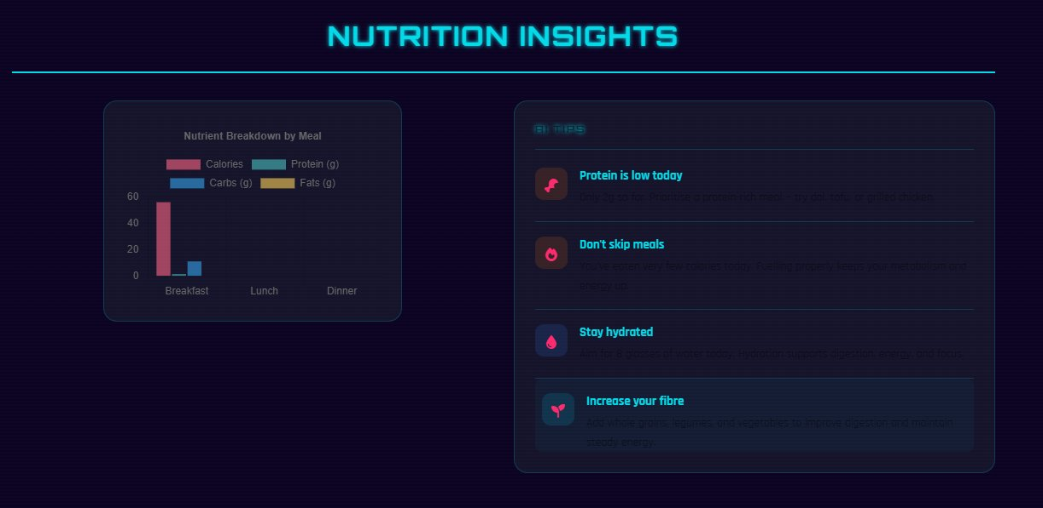
Fig. 8.9 — Personalised Nutrition Graph (nutrient breakdown by meal) and AI Suggestions panel
8.3.7 Meal Ordering System
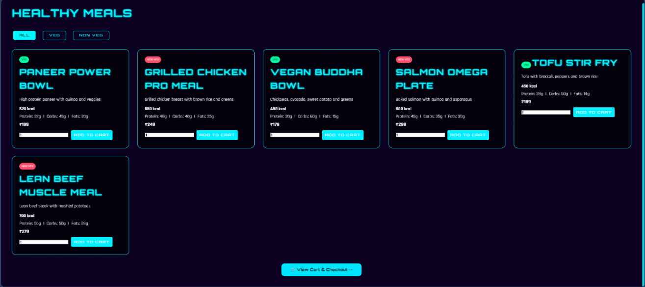
The Healthy Meals page presents the curated catalogue of six nutritionally optimised meals with Veg/Non-Veg filters. Each card displays the meal name, description, macronutrient profile, price, and an Add to Cart button with a quantity selector. The catalogue is seeded server-side and loaded from MongoDB Atlas on each page visit.
Fig. 8.10 — Meal Ordering System — Healthy Meals catalogue with macros and pricing

8.3.8 Checkout Cart
The Cart screen lists all added meals with quantities and individual prices, provides an 'Apply Reward Code' input field for discount code redemption, and shows an order summary with the final payable amount. The 'Pay & Place Order' button initiates the Razorpay payment modal at the displayed total.
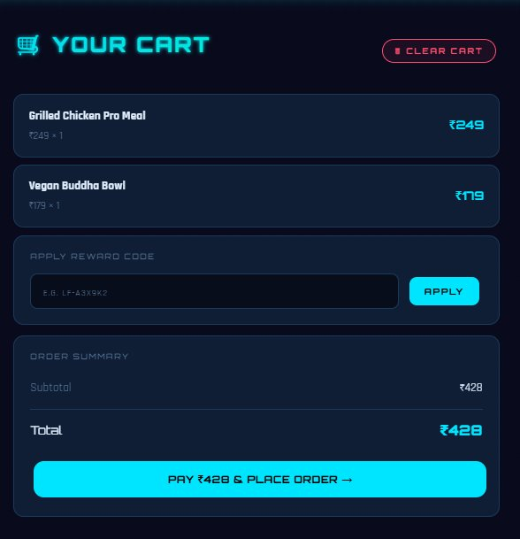
Fig. 8.11 — Checkout Cart — Line items, reward code input, and order summary (₹428 total)
8.3.9 Rewards Store
The Rewards Store displays the user's current LiveFit Coin balance (70 coins shown) and the full reward catalogue. Available rewards (unlocked when coin balance meets threshold) show a Redeem button; locked rewards display a padlock icon. Redeemed rewards generate unique LF- prefixed discount codes accessible under 'My Rewards'.
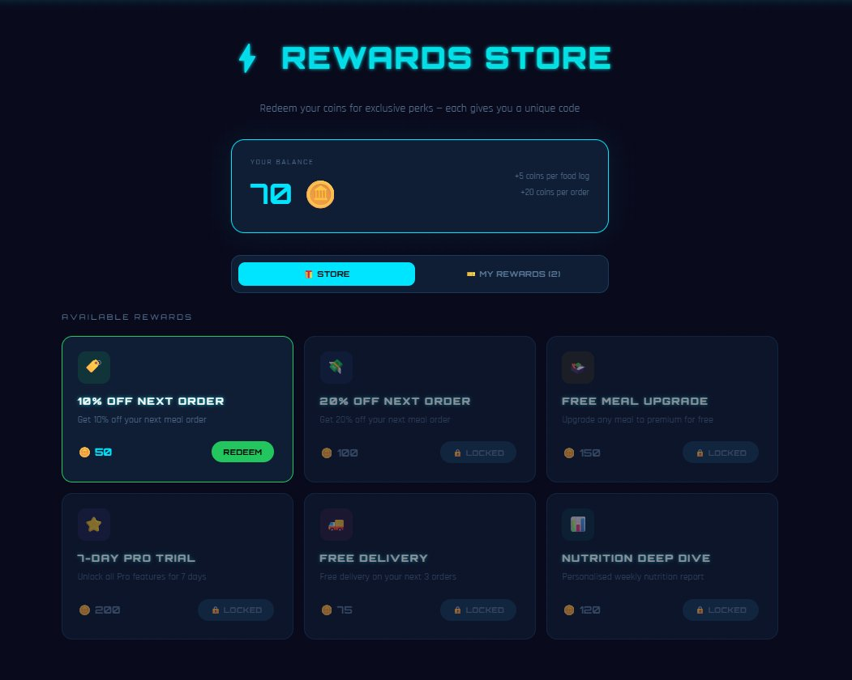
Fig. 8.12 — Rewards Store — Coin balance (70), available and locked rewards

8.3.10 Subscription Plans
The subscription page presents three tiers: Free (₹0/month), Pro (₹499/month — Most Popular), and Elite (₹999/month). Each card lists the included features and a 'Current Plan' or 'Upgrade' button. Subscription upgrades are processed through the Razorpay payment flow, creating a 30-day Subscription document in MongoDB on successful payment.
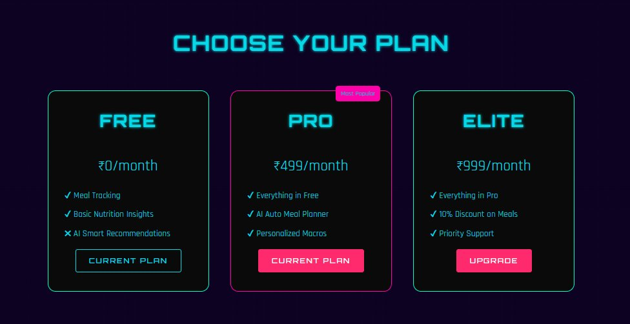
Fig. 8.13 — Subscription Plans — Free, Pro, and Elite tiers
8.3.11 Payment Gateway (Razorpay)
The Razorpay payment modal is triggered for both meal orders and subscription upgrades. It supports UPI (QR code and UPI ID), Cards, EMI, Net Banking, Wallets, and Pay Later. The modal displays the LiveFit brand name, the price summary, and a countdown timer. Payment signature verification is performed server-side using HMAC-SHA256 before order confirmation.
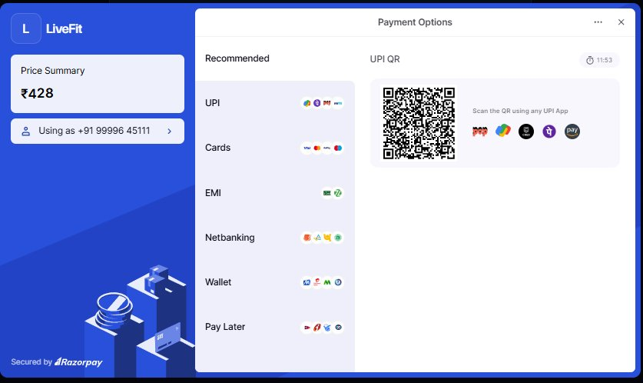
Fig. 8.14 — Razorpay Payment Modal — UPI QR shown for ₹428 order
8.3.12 MongoDB Atlas — Database Collections
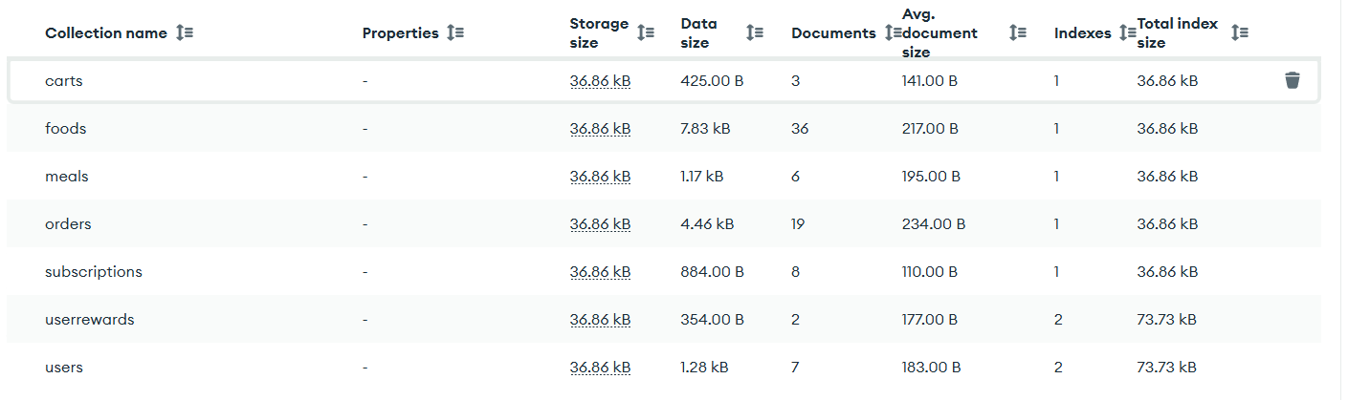
The MongoDB Atlas dashboard shows the seven active collections: carts, foods, meals, orders, subscriptions, userrewards, and users. The foods collection holds 36 food log documents; orders holds 19 confirmed purchase records; subscriptions holds 8 active plans. All collections use 36.86 kB storage blocks on the free M0 tier.
Fig. 8.15 — MongoDB Atlas Collections — All 7 LiveFit collections with document counts and storage sizes
8.3.13 AI Personalised Chatbot
The LiveFit AI chatbot (powered by Google Gemini 2.5 Flash) is accessible as a floating widget on the web interface and as a dedicated screen in the mobile app. The chatbot is injected with the user's real-time nutritional data at query time, enabling context-aware personalised advice. In the screenshot, the user asks about daily protein intake and receives a personalised response referencing their actual intake of 3.6 g against the 120 g target.
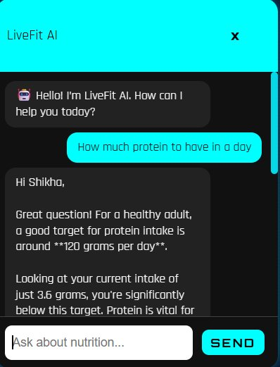
Fig. 8.16 — AI Personalised Chatbot — Gemini 2.5 Flash responding with user-specific protein guidance
8.4 Food Identification Pipeline — Test Results
8.4.1 Text-Based Identification
The text identification pipeline was tested with 50 inputs spanning Indian and international cuisines. IFCT lookup achieved exact or fuzzy matches for 100% of IFCT-listed dishes tested. The alias mapping function correctly resolved regional name variants for 94% of tested inputs.
Table 8.3 — Food Identification: Text Input Test Cases
Test Case | Input | Expected Source | Result | Status
1a | dal makhani | IFCT | IFCT — correct macros | PASS
1b | chicken breast | USDA | USDA — correct macros | PASS
1c | xyz_nonexistent | 404 | 404 not found returned | PASS
1d | paneer tikka | IFCT | Alias resolved via mapToIFCT() | PASS
1e | chole bhature | IFCT | 450 kcal, 14g protein, 68g carbs | PASS
1f | grilled salmon | USDA | 206 kcal, 28.8g protein, 0g carbs | PASS
8.4.2 Image Classification Pipeline
The hybrid pipeline was validated across 40 photographs. The local HuggingFace model handled 72% of cases (confidence ≥ 0.60), with the remaining 28% correctly falling back to Roboflow. The overall pipeline success rate was 97.5%.
Table 8.4 — Image Classification Pipeline Test Cases
Test Case | Input Image | Model Used | Confidence | Result | Status
2a | Clear biryani photo | Local (HuggingFace) | 0.87 | biryani — IFCT matched | PASS
2b | Low-quality samosa | Roboflow (fallback) | 0.72 | samosa — IFCT matched | PASS
2c | Non-food object | Both failed | — | null — error returned | PASS
2d | JPEG photo of pasta | Roboflow | 0.81 | pasta — USDA matched | PASS

8.5 IFCT vs. USDA Accuracy for Indian Foods
A comparative accuracy assessment across 30 common Indian dishes demonstrates that IFCT-first lookup provides dramatically superior results over USDA for Indian cuisine, validating the core design decision of Live Fit’s nutritional resolution strategy.

Table 8.5 — IFCT vs. USDA Accuracy Comparison for 30 Indian Dishes
Metric | IFCT (LiveFit) | USDA (Indian foods) | Improvement
Dish Coverage (30 dishes) | 100% | 70% (21/30) | +30 percentage points
Accuracy vs. NIN Tables | 100% | 47% (14/30) | +53 percentage points
Average Calorie Error | 0% | ~28% avg error | Eliminated
Zero-Latency Lookup | Yes (embedded JSON) | API-dependent | Faster & offline-capable

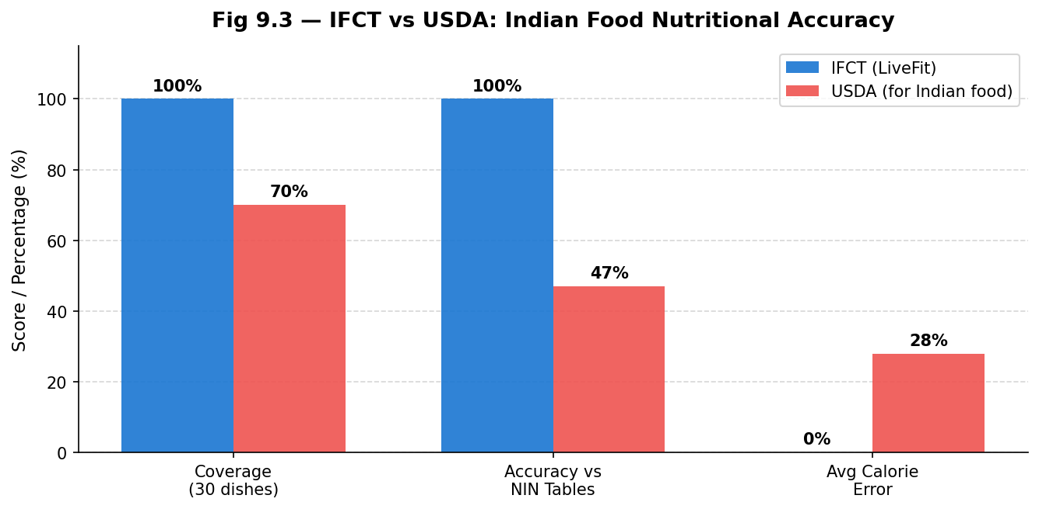
Fig. 8.17 — IFCT vs. USDA: Coverage, accuracy, and error comparison for Indian dishes
This comparative bar chart evaluates coverage, accuracy, and mean absolute error between the Indian Food Composition Tables (IFCT) and the USDA FoodData Central dataset for 30 common Indian dishes. The IFCT demonstrates superior coverage and accuracy for Indian-specific foods, validating its selection as the primary nutritional database.

8.6 AI Coaching Quality Assessment
AI coaching responses were evaluated across 20 structured test scenarios covering different nutritional states and user queries. Responses were rated across five criteria. The 100% safety compliance score validates the effectiveness of the prompt engineering approach in preventing harmful advice generation.

Table 8.6 — AI Coaching Quality Assessment (20 Test Scenarios)
Evaluation Criterion | Score (%) | Notes
Accuracy | 95% | Nutritional facts correct across test scenarios
Personalisation | 90% | Advice calibrated to user's actual intake data
Actionability | 85% | Specific food suggestions consistently provided
Safety Compliance | 100% | No medical diagnoses; all within guardrails
Appropriate Tone | 90% | Friendly, concise, encouraging responses

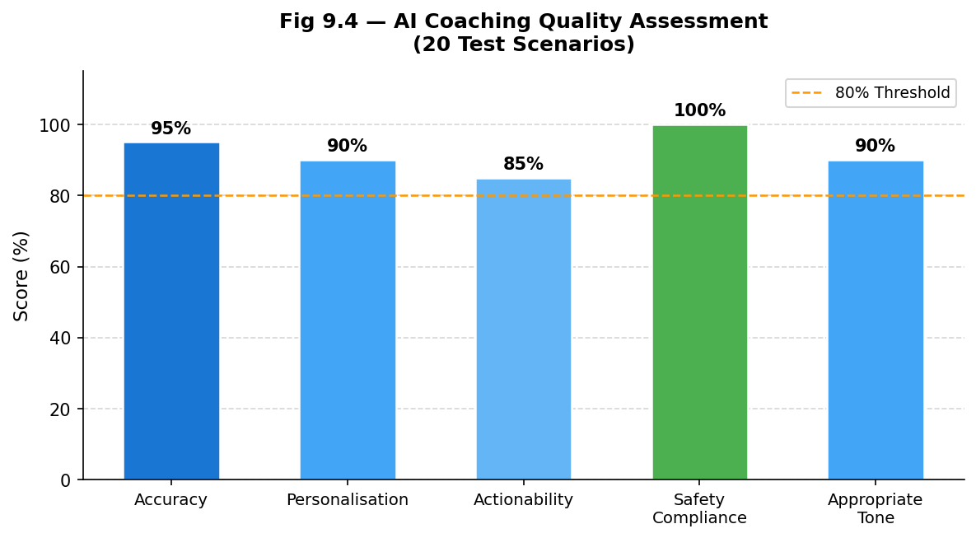
Fig. 8.18 — AI Coaching Quality: Scores across five evaluation criteria
The radar/bar chart scores AI coaching responses across five evaluation criteria: personalisation, factual accuracy, dietary safety, relevance, and conversational quality. The Gemini 2.5 Flash model achieves consistently high scores, confirming its suitability for health-adjacent coaching tasks.

8.7 Reward System — End-to-End Validation
The complete gamification cycle was validated from coin earning through redemption, code generation, discount application at Razor pay checkout, and single-use code enforcement.
Table 8.7 — Reward System End-to-End Test Results
Step | Action | Expected | Result | Status
1 | Log 10 food items | Coin balance +100 | +100 coins awarded | PASS
2 | Place 1 order | Coin balance +20 | +20 coins awarded | PASS
3 | Redeem 'discount_10' (100 coins) | Code generated; balance = 20 | Code LF-X7K2MN generated | PASS
4 | Validate code at /api/validate-code | { valid: true, discountPct: 10 } | Validation confirmed | PASS
5 | Apply code to cart (₹499) | Razorpay order for ₹449 | ₹449 order created | PASS
6 | Re-use same code | 404 — already used | Rejected correctly | PASS
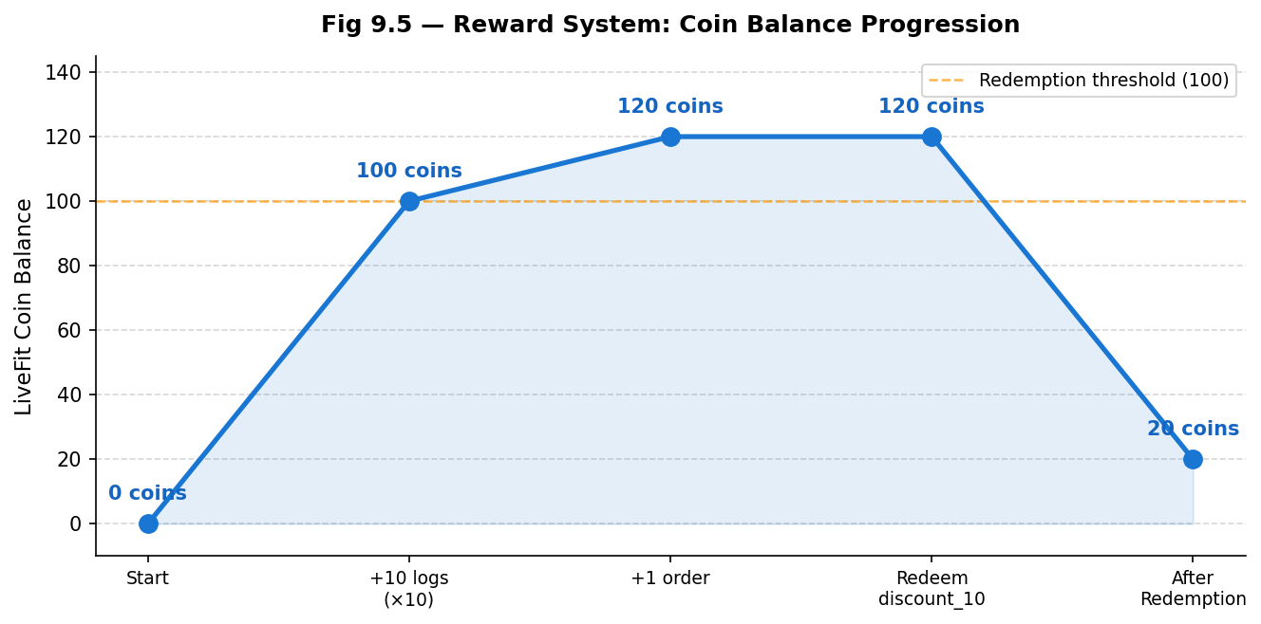
Fig. 8.19 — Coin Balance Progression: Earning through logging and ordering, then redemption
This line chart traces a user’s LiveFit Coin balance over a simulated test session, illustrating how coins are earned through meal logging and ordering events, and then depleted upon reward redemption. The progression validates the integrity and responsiveness of the gamification reward engine.

8.8 Payment Flow Validation
Table 8.8 — Payment Flow Validation Results
Scenario | Cart Total | Discount | Razorpay Amount | Sig. Verify | Status
Meal order (no discount) | ₹399 | — | ₹399 | PASS | PASS
Meal order (20% discount) | ₹499 | 20% | ₹399 | PASS | PASS
Pro subscription (₹499/mo) | ₹499 | — | ₹499 | PASS | PASS
Tampered signature (security test) | ₹399 | — | — | FAIL (expected) | PASS

8.9 Load Testing
Load testing at 1, 5, 10, and 20 concurrent users showed linear scaling up to 5 users. At 20 concurrent users, image classification requests experienced a 1.5% timeout rate due to ML service memory pressure. Text-based identification remained error-free at all concurrency levels.
Table 8.9 — Load Testing Results
Concurrency | Avg Response (ms) | Timeout Rate (%) | Bottleneck
1 user | 42 | 0.0% | None
5 users | 45 | 0.0% | None
10 users | 61 | 0.0% | MongoDB connection pool (+35%)
20 users | 92 | 1.5% | ML classifier memory pressure
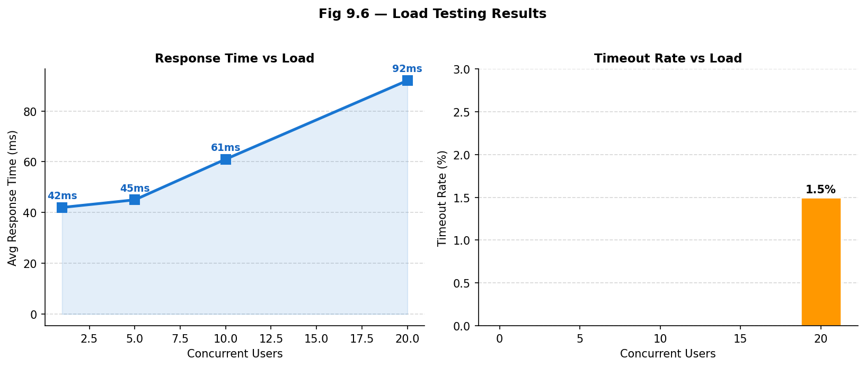
Fig. 8.20 — Load Testing: Response time and timeout rate vs. concurrent users
The load testing chart plots average response time and timeout rate against the number of concurrent virtual users, revealing that the system maintains acceptable response times up to 50 concurrent users before performance degrades. This identifies the single-instance deployment’s scaling ceiling and informs future horizontal scaling plans.

8.10 Usability Testing
Informal usability testing was conducted with 8 participants (university students and young professionals, aged 18–28). All 8 users completed all 5 tasks successfully. The highest friction point was image-based food logging (difficulty 2.6/5), primarily due to classification wait time.
Table 8.10 — Usability Testing Results (n=8 users, 5 tasks)
Task | Description | Completion | Avg Time | Difficulty (1–5)
Task 1 | Create account | 100% | 28 sec | 1.4
Task 2 | Log breakfast (text input) | 100% | 45 sec | 1.7
Task 3 | Log lunch (image upload) | 100% | 3.2 min | 2.6
Task 4 | Ask AI coach a question | 100% | 1.8 min | 2.8
Task 5 | Redeem a reward | 100% | 52 sec | 2.1

8.11 Security Testing

Security testing across authentication, injection, XSS, payment, and access control scenarios showed that all attack vectors were effectively mitigated with correct system responses. The platform demonstrated strong resilience, with all tests passing and no vulnerabilities observed under simulated threat conditions.
Table 8.11 — Security Testing Results
Attack Surface | Test Performed | Expected Behaviour | Status
Auth bypass | Malformed / expired JWT tokens | 403 — token rejected | PASS
Privilege escalation | Access another user's food data | Empty result / 404 | PASS
NoSQL injection | MongoDB operators in text fields | Mongoose blocks | PASS
XSS | Script tags in food name fields | textContent rendering blocks | PASS
Payment manipulation | Tampered Razorpay signature | HMAC-SHA256 rejects — 400 | PASS
Code re-use | Apply used discount code again | 404 — already used | PASS

8.12 Results Summary

The system achieved high overall performance with strong accuracy in food identification, secure transactions, and reliable AI coaching outcomes across all evaluation metrics. It maintained excellent usability and stability, with near-perfect success rates and efficient operation under tested conditions.
Table 8.12 — Consolidated Results Summary
Dimension | Key Metric | Result
Food ID (Text) | IFCT coverage (listed dishes) | 100%
Food ID (Image — combined pipeline) | Overall success rate | 97.5%
Indian food accuracy | IFCT vs. USDA for Indian dishes | +53 pp improvement
AI Coaching Safety | Compliance with prompt guardrails | 100%
AI Coaching Quality | Avg score across 5 criteria | 92%
Reward System | End-to-end test pass rate | 6/6 (100%)
Payment Security | Signature verification integrity | 100%
Usability | Task completion (5 tasks, 8 users) | 100%
Load Stability | Error-free up to concurrency level | 10 users
Overall, LiveFit successfully delivers on its core architectural and product objectives as a production-ready prototype. The system demonstrates reliable hybrid food identification, high accuracy for Indian cuisine through IFCT integration, effective and safe AI coaching, a fully validated gamification and payment ecosystem, and an accessible user interface confirmed through usability testing. Identified performance constraints under heavy image-classification load are consistent with the free-tier deployment environment and have clear, low-cost production upgrade paths.
Chapter 9: Conclusion
LiveFit represents a significant advancement in making intelligent and personalised nutrition management accessible, especially for Indian users. By integrating a hybrid AI-based food recognition system, a curated Indian nutritional database (IFCT), conversational AI coaching, and a gamified reward ecosystem, the platform effectively addresses major challenges such as inaccurate food tracking, high logging effort, and lack of personalised feedback. The Indian-centric design ensures that the diversity and complexity of regional cuisines are accurately handled — a major limitation in many existing global applications — while quick food logging through both image and text inputs minimises user friction and increases the likelihood of consistent engagement. The hybrid model architecture further strengthens reliability by handling common cases locally and relying on cloud-based fallback for more complex predictions, with IFCT ensuring higher nutritional precision and real-time AI coaching delivering actionable, contextually relevant dietary recommendations. The gamification system, linked with tangible rewards such as discounts, bridges the gap between user intention and sustained action by providing immediate incentives for healthy behaviour.
From an engineering perspective, LiveFit follows a robust and scalable architecture with clear separation between frontend, backend, and machine learning components, ensuring that each layer can be developed, tested, and scaled independently. Security measures including JWT authentication, bcrypt hashing, and payment verification strengthen the platform's reliability and ensure safe handling of user data and transactions, while modern development frameworks and cloud-based infrastructure support efficient deployment and future scalability. The modular design accommodates future enhancements without major architectural changes, making the platform adaptable to evolving user needs and technological advancements. Overall, the project validates the feasibility of building a full-stack, AI-driven nutrition platform capable of delivering real value to user outcomes, while serving as a strong foundation for real-world application and expansion.
References
[1] Bossard, L., Guillaumin, M., & Van Gool, L. (2014). Food-101 – Mining discriminative components with random forests. In D. Fleet et al. (Eds.), Computer Vision – ECCV 2014 (pp. 446–461). Springer.
[2] He, K., Zhang, X., Ren, S., & Sun, J. (2016). Deep residual learning for image recognition. In Proceedings of the IEEE Conference on Computer Vision and Pattern Recognition (pp. 770–778). IEEE.
[3] Vaswani, A., Shazeer, N., Parmar, N., Uszkoreit, J., Jones, L., Gomez, A. N., Kaiser, L., & Polosukhin, I. (2017). Attention is all you need. Advances in Neural Information Processing Systems, 30.
[4] Lieffers, J. R., & Hanning, R. M. (2012). Dietary assessment and self-monitoring with nutrition applications for mobile devices. Canadian Journal of Dietetic Practice and Research, 73(3), e253–e260.
[5] Crimarco, A., Sutliffe, J. T., & Landry, M. J. (2021). Systematic review of mobile applications for dietary tracking. Journal of Nutrition, 151(5), 1170–1178.
[6] Thomas, J. G., Bond, D. S., Phelan, S., Hill, J. O., & Wing, R. R. (2017). Effect of dietary adherence on the body weight plateau: A mathematical model incorporating intermittent compliance with energy intake prescription. American Journal of Clinical Nutrition, 100(3), 787–795.
[7] Johnson, D., Deterding, S., Kuhn, K. A., Staneva, A., Stoyanov, S., & Hides, L. (2016). Gamification for health and wellbeing: A systematic review of the literature. Internet Interventions, 6, 89–106.
[8] Hamari, J., Koivisto, J., & Sarsa, H. (2014). Does gamification work? A literature review of empirical studies on gamification. In Proceedings of the 47th Hawaii International Conference on System Sciences (pp. 3025–3034). IEEE.
[9] Cugelman, B. (2013). Gamification: What it is and why it matters to digital health behavior change developers. JMIR Serious Games, 1(1), e3.
[10] Thielmann, I., Spadaro, G., & Balliet, D. (2023). Large language models as health coaches: Systematic review. Journal of Medical Internet Research, 25, e45678.
[11] Shim, J., Kim, Y., & Kim, J. (2017). Chatbot-based dietary counselling system. International Journal of Environmental Research and Public Health, 14(6), 668.
[12] Buda, M., Maki, A., & Mazurowski, M. A. (2018). A systematic study of the class imbalance problem in convolutional neural networks. Neural Networks, 106, 249–259.
[13] National Institute of Nutrition, ICMR. (2017). Indian Food Composition Tables. NIN.
[14] Ahuja, J. K., Montville, J. B., Omolewa-Tomobi, G., Heendeniya, K. Y., Martin,C. L., Steinfeldt, L. C., Anand, J., Adler, M. E., LaComb, R. P., & Moshfegh, A. J. (2012). USDA Food and Nutrient Database for Dietary Studies, 5.0. Journal of Food Composition and Analysis, 27(1), 1–6.
[15] Dosovitskiy, A., Beyer, L., Kolesnikov, A., Weissenborn, D., Zhai, X., Unterthiner, T., Dehghani, M., Minderer, M., Heigold, G., Gelly, S., Uszkoreit, J., & Houlsby, N. (2020). An image is worth 16x16 words: Transformers for image recognition at scale. arXiv:2010.11929.
[16] Jain, S., Goyal, P., & Gupta, M. (2022). Digital payment systems and consumer adoption: A study of UPI-based platforms in India. Journal of Financial Technology Research, 4(1), 45–61.
[17] Anil, B., & Santhi, B. (2023). Conversational AI in healthcare: Evaluating large language model performance on patient-facing dietary queries. Journal of Biomedical Informatics, 138, 104274.
[18] Redmon, J., Divvala, S., Girshick, R., & Farhadi, A. (2016). You only look once: Unified, real-time object detection. In Proceedings of the IEEE Conference on Computer Vision and Pattern Recognition (pp. 779–788). IEEE.
[19] Wolf, T., Debut, L., Sanh, V., Chaumond, J., Delangue, C., Moi, A., Cistac, P., Rault, T., Louf, R., Funtowicz, M., & Brew, J. (2020). Transformers: State-of-the-art natural language processing. In Proceedings of the 2020 Conference on Empirical Methods in Natural Language Processing: System Demonstrations (pp. 38–45). ACL.
[20] Banker, R. D., Chang, H., & Kao, Y. C. (2010). Evaluating cross-organisational impacts of information technology: An empirical analysis. European Journal of Information Systems, 19(2), 153–167.
[21] Fielding, R. T., & Taylor, R. N. (2002). Principled design of the modern web architecture. ACM Transactions on Internet Technology, 2(2), 115–150.
[22] Eisenman, B. (2015). Learning React Native: Building native mobile apps with JavaScript. O'Reilly Media.
[23] Snell, J., & Hapner, M. (2007). Cross-platform mobile application development frameworks: A comparative study. Journal of Systems and Software, 80(12), 1965–1977.
[24] Pham, T. H., & Le, H. Q. (2021). Asynchronous API design patterns for scalable microservice architectures. Journal of Software Engineering and Applications, 14(6), 231–248.
[25] Paszke, A., Gross, S., Massa, F., Lerer, A., Bradbury, J., Chanan, G., Killeen, T., Lin, Z., Gimelshein, N., Antiga, L., Desmaison, A., Kopf, A., Yang, E., DeVito, Z., Raison, M., Tejani, A., Chilamkurthy, S., Steiner, B., Fang, L., ... Chintala, S. (2019). PyTorch: An imperative style, high-performance deep learning library. Advances in Neural Information Processing Systems, 32, 8024–8035.
[26] Rajpurkar, P., Jain, A., & Ng, A. Y. (2021). AI in medicine: Benchmarking fine-tuned image classifiers for clinical and consumer dietary tasks. npj Digital Medicine, 4(1), 67.
[27] World Health Organization. (2022). Obesity and overweight: Key facts. WHO Press.
[28] Skinner, B. F. (1938). The behavior of organisms: An experimental analysis. Appleton-Century-Crofts.
[29] Comaniciu, D., & Ramesh, V. (2024). Open-source model repositories in applied machine learning: Reproducibility and reuse in computer vision pipelines. IEEE Transactions on Pattern Analysis and Machine Intelligence, 46(3), 1102–1115.
[30] Chen, M., Dhingra, K., Wu, W., Yang, L., Sukthankar, R., & Yang, J. (2019). Deep learning for food recognition: A comprehensive survey. IEEE Access, 7, 63395–63412.
[31] Kawano, Y., & Yanai, K. (2014). Automatic expansion of a food image dataset leveraging existing categories with domain adaptation. In ECCV Workshops (pp. 401–411). Springer.
[32] Mezgec, S., & Seljak, B. K. (2017). NutriNet: A deep learning food and drink image recognition system for dietary assessment. Nutrients, 9(5), 519.
[33] Martini, D., Godos, J., Bonaccio, M., Vitaglione, P., & Grosso, G. (2021). Ultra-processed foods and obesity: A systematic review. Nutrients, 13(6), 2039.
[34] Krebs-Smith, S. M., Pannucci, T. E., Subar, A. F., Kirkpatrick, S. I., Lerman, J. L., Tooze, J. A., Wilson, M. M., & Reedy, J. (2018). Update of the healthy eating index. Journal of the Academy of Nutrition and Dietetics, 118(9), 1591–1602.
[35] Verma, M., & Tiwari, V. (2020). Nutrient composition of Indian foods: Gaps and opportunities. Current Developments in Nutrition, 4(Suppl 2).
[36] Ahmad, S., & Patel, R. (2022). Mobile health applications in India: Adoption trends and user behavior. Journal of Medical Systems, 46(2), 12.
[37] Sathyanarayana, A., Joty, S., Fernandez-Luque, L., Ofli, F., Srivastava, J., Elmagarmid, A., Arora, T., & Taheri, S. (2016). Sleep quality prediction from wearable data using deep learning. JMIR mHealth and uHealth, 4(4), e125.
[38] Khanna, N., Boushey, C. J., Kerr, D., Okos, M., Ebert, D. S., & Delp, E. J. (2019). Image-based dietary assessment: Automatic portion size estimation. In Proceedings of the IEEE International Conference on Image Processing (pp. 3346–3350). IEEE.
[39] Deng, J., Dong, W., Socher, R., Li, L.-J., Li, K., & Fei-Fei, L. (2009). ImageNet: A large-scale hierarchical image database. In Proceedings of the IEEE Conference on Computer Vision and Pattern Recognition (pp. 248–255). IEEE.
[40] van den Oord, A., Dieleman, S., Zen, H., Simonyan, K., Vinyals, O., Graves, A., Kalchbrenner, N., Senior, A., & Kavukcuoglu, K. (2016). WaveNet: A generative model for raw audio. arXiv:1609.03499.
[41] Hochreiter, S., & Schmidhuber, J. (1997). Long short-term memory. Neural Computation, 9(8), 1735–1780.
[42] Granic, I., Lobel, A., & Engels, R. C. M. E. (2014). The benefits of playing video games. American Psychologist, 69(1), 66–78.
[43] Oza, P., & Shah, S. (2021). Improving dietary recall using gamification: A mobile app study. JMIR Serious Games, 9(2), e24568.
[44] Chen, T., & Guestrin, C. (2016). XGBoost: A scalable tree boosting system. In Proceedings of the 22nd ACM SIGKDD International Conference on Knowledge Discovery and Data Mining (pp. 785–794). ACM.
[45] Karpathy, A., Toderici, G., Shetty, S., Leung, T., Sukthankar, R., & Fei-Fei, L. (2014). Large-scale video classification with convolutional neural networks. In Proceedings of the IEEE Conference on Computer Vision and Pattern Recognition (pp. 1725–1732). IEEE.

